INTRODUCTION

OF

MPF1612 COAL MILL

SHENYANG HEAVY M&M MACHINERY CO.,LTD.
2008/11

Catalogue
- Preface

Introduction of the Function about MP Coal Mill
- 1.0 MP Coal Mill
- 1.1 Performance of Coal Mill
- 1.2 Scope of Supply
- 1.3 Introduction of the Performance about Each Component
A. 1.4 Technical Data
- 2.0 Speed Reducer of Coal Mill
- 2.1 Function of Speed Reducer
A. 2.2 Function of Speed Reducer Parts
A. 2.3 Technical Data
- 3.0 Turning Gear of MP Coal Mill
- 3.1 Function of Turning Gear
- 3.2 Function of Turning Gear Parts
- 3.3 Technical Data

MP Coal Mill Operation
B. 1.0 MP Coal Mill
B. 1.1 Outline
B. 1.2 Preparation for Coal Mill Start-up
B. 1.3 Coal Mill Start-up and Working
B. 1.4 The Stop of Coal Mill
B. 1.5 Urgent Stop of Coal Mill
B. 1.6 Steam Enter into Coal Mill
B. 1.7 Technical Data of Coal Mill Operating and Working
B. 1.8 Control Diagram
B. 2.0 Speed Reducer of MP Coal Mill
B. 2.1 Preparation for Working
B. 2.2 Preparation for Restart after Stop
B. 2.3 Operation on Speed Reducer when Using Turning Gear
B. 2.4 Operation of Speed Reducer
B. 2.5 Inspection When Stop
B. 2.6 Technical Data
B. 3.0 Turning Gear of MP Coal Mill
B. 3.1 Outline
B. 3.2 Inspection before Use
B. 3.3 Operation
B. 3.4 Operation after Stop
- 1.0 Coal Mill and Static Classifier
C. 1.1 Accident Prevention at Maintenance, Inspection and Repair
C. 1.2 Coal Mill Care and Service When Stop
C. 1.3 Assembly and Disassembly of Wearing Resistant Parts and Coal Mill Internal Parts
C. 1.4 Maintenance of Coal Mill Components
C. 1.5 Spare Parts
C. 1.8 The Causes and Treatments of Coal Mill Malfunction
C. 1.9 Hydraulic System of Coal Mill
C. 1.10 Coal Mill Lubrication List
- Introduction of MP Coal Mill Installation
- 1. Preface
D. 2. Foundational Leveling
D. 3. Bottom Plate of Coal Mill
D. 4. Speed Reducer of Coal Mill
D. 5. Bottom Housing
D. 6. Sealing Ring of Bottom Housing
D. 7. Grinding Track Carrier
D. 8. Intermediate Housing
D. 9. Scraper
D. 11. Grinding Track
D. 12. Grinding Roll
D. 13. Compression Plate
D. 14. Sealing Air Duct of Grinding Roll
D. 15. Tension Device
D. 16. Measuring Device
D. 17. Classifier
D. 18. Reject Box
D. 19. Sealing Air-Blower
D. 20. Sealing Air Duct Outside Coal Mill
D. 21. Pressure Oil Lubricating System
D. 22. Hydraulic System
D. 23. Monitoring Device
D. 24. Steam Enter System
D. 25. Platform and Ladder
D. 26. Motor
D. 27. Concrete Pouring on the Top Layer
D. 28. Heat Insulation
D. 29. Grounding
D. 30. Welding on the Coal Mill
D. 31. Handover
D. 32. Transportation and Lifting Weight of Major Parts

Operational Instructions
- Preface
The operational instruction includes a brief introduction about the equipment, the functions of every part of the equipment, comprehensive instructions on operation and on the repair of its major parts.
These instructions are not an integrated illustration for the boiler operating system, so it can’t take the place of the training of operators.
The equipment producer is not responsible for the damage of the equipment caused by incorrect operations, incorrect repairs, deliberate damages, or becoming rusty due to inappropriate storage.
When the equipment is operating, it should be inspected regularly. There should be effective connections between the main control room and every operating branch.
In order to keep safety of the equipment operation, necessary maintenances of the equipment should be carried on continuously. Any accident caused by inappropriate maintenances of the equipment, the manufacturer will not take the responsibility.

A. 1.0. MPF Coal Mill

A. 1.1. Performance of coal mill
MPF coal mill is a grinder with three fixed outside force type grinding rolls. The three rolls make a rolling movement on one circumrotating grinding track. The materials fall onto the grinding track

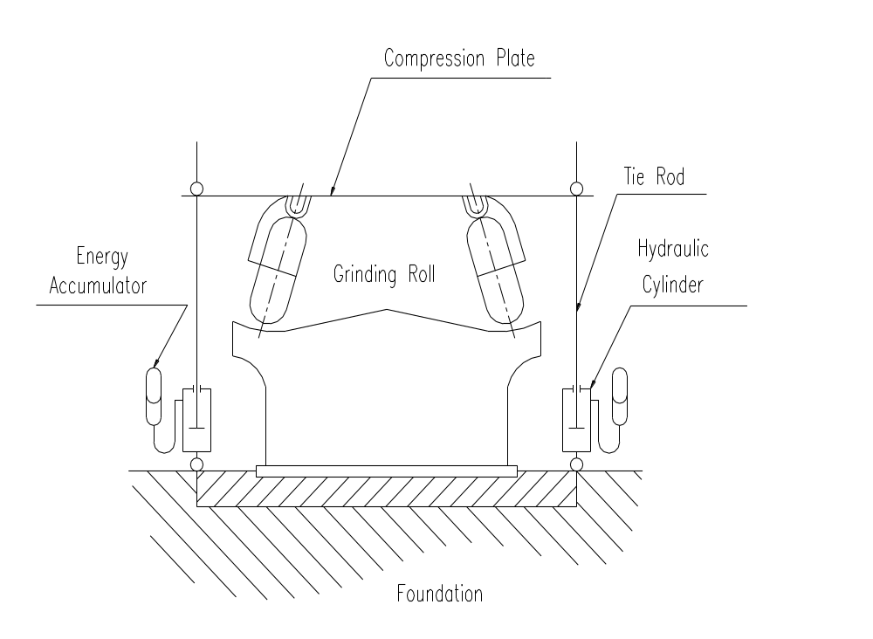

through the central coal pipe of the grinder. The circumrotating grinding track transports the materials to milling roll path with the help of centrifugal force and mills them with grinding rolls. The three grinding rolls are all on the grinding track rail circumferentially. The grinding force put by the grinding rolls is produced by hydraulic cylinder. By adding force to the three grinding rolls by the three-point systematic force, the pressure of grinding track and grinding rolls are transported to the foundation through soleplate, tie rod and hydraulic cylinder. The grinding and desiccating process occur simultaneously. The hot air enters the grinding track equably through spray nozzle ring, dryings the shattered materials and transports them to the air flow classifier with static vane on the top of the grinder. In the classifier, the materials are separated according to their different degree of thickness. The thinner powder is discharged and the thicker powder comes back to the grinding track for further grinding.

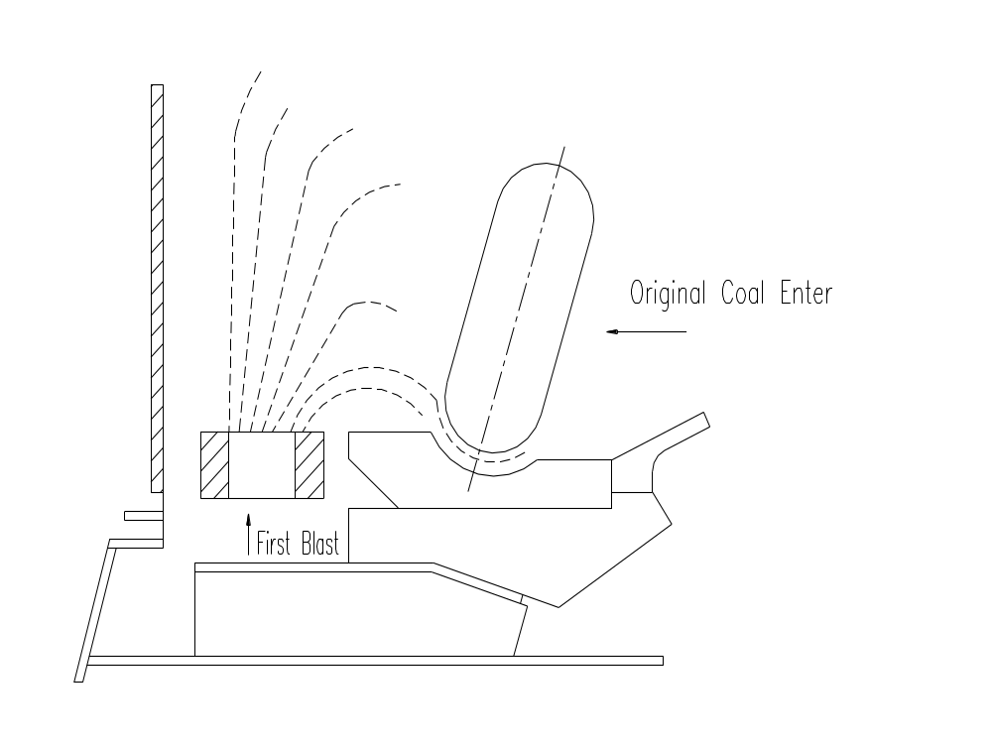

The materials that are difficult to grind cannot be blown away. They fall down to the hot air room underside through spray nozzle ring, enter the reject box through the scraper and then are discharged. The process of cleaning out the waste can be also carried on when the mill is running.
MPF coal mill is driven by asynchronous motor of the mouse cage type.
The reducer transports the motive power supplied by the motor to the grinding track, and adjusts the rotate speed to the working speed of the mill. It also carries on the milling pressure and the multiple-duty.
When repairing the mill, the turning device can be connected to the tail of the motor.

A.1.2. Instruction of components performance

A.1.2.1. Fundamental Parts
The bottom plate used for fixing the speed reducer, tie rod and motor bed should be adjusted well before double grouting. The rail pulled by reducer should be on the same level with the speed reducer bed. Then joint and fix, and cover it up in the foundation when double grouting.
A.1.2.2 Bottom Housing
The bottom housing of the mill in jointing structure has the following functions:
Supporting the intermediate housing of the coal mill and the classifier.
Fixing sealing ring of bottom housing.

A.1.2.3 Intermediate housing
There is an entrance for first hot air and hot air oriented device welded on the intermediate housing of the coal mill. The columnar intermediate housing seals the grinding parts. Its inner wall is welded with wear-resisting steel plate. There is a sealing door in each of the four walls for repairing, as well as an inspection door used for observing the scale of damage of the grinding rolls and the spray nozzle ring. The intermediate housing is equipped with tie rod sealing device, spray nozzle ring fixing device and compression plate position-limiting device as well

A.1.2.4 Grinding Track Carrier and Scraper
The grinding track carrier and the speed reducer are rigidly connected. It is used for passing twisting moment. The grinding track carrier and the sealing ring of bottom housing form a sealed air passage of the ring shape in order to prevent the hot air with flange from infecting the speed reducer. The waste scraper is fixed onto the grinding track carrier, and grinding track carrier is fixed onto the output flange of the speed reducer.
A.1.2.5 Spray Nozzle Ring
The spray nozzle ring circles the grinding track. It includes two parts：Upper and bottom parts.

A.1.2.6 Grinding Track
The grinding track is embedding with hard nickel alloy grinding track liner, which is wear-resisting. The liner is fixed by wedge clamp bolt. There is a central cover plate used for distributing materiel and preventing water and powder from entering the bottom space. There is a positioning pin on the grinding track to prevent the relative movement of every part. The grinding track is put on the corresponding grinding track carrier.

A.1.2.7 Grinding Roll
Grinding rolls bearing carry all the deadweight, grinding pressure and the counterforce produced by grinding rolls oriented effect. Therefore the grinding roll bearing is designed according to the special need. As the lifespan of grinding rolls bearing depends on the lubricating condition, enough attention should be paid to lubricating issues. As for the maximum infusing quantity of grinding roll lubrication, see the technical data in B.1.7.1. The minimum oil infusing quantity should ensure the sealing ring of roll shaft immersed into the oil. In order to prevent leakage and the dust from entering the bearing, pay attention to keep a good sealing state. It shall inject with efficient lubrication into the space among shaft sealing ring. The movable pipe connected with sealing blast system shall lead to grinding bracket. The sealing blast flows into the annular space through the empty cavity in the grinding bracket. In order to eliminate the disadvantageous effects brought by different temperature and pressure, the end of the grinding roll bearing is fixed with a filter.
There is an inspection hole to measure the level of oil on the roll shaft. Tighten the screws after using it.
The roll sleeve of the grinding roll is made of hard nickel alloy. It is well proportioned, and it can rotate on a given wearing condition. The cover is assorted into the hub and fixed by hold-down ring. There are thrust piece in the three channel-shape gap to prevent them from rotation.
A. 1.2.8 Oriented Device and Compression Plate
The oriented device is installed on the three bulgy parts on the intermediate housing of the coal mill. It can make the compression plate and the grinding roll move vertically along a wide range.
Each grinding roll makes position adjustment on the compression plate through two roll column gemels. Each roll column on the grinding roll bracket can rotate along the radial direction. So the grinding roll can adjust its position horizontally on the grinding track roll rail automatically. If necessary, the pitch of the grinding roll can be adjusted by this mechanism.
The connecting board connects the compression plate and the grinding roll frame.
A.1.2.9 Tie Rod Mechanism, the Thickness of Coal bed measuring device
The tie rod is linked with the compression plate by spherical movable joint. The other side of the tie rod is connected by nut and the piston rod of hydraulic cylinder. There is joint bearing at the bottom of the hydraulic cylinder, by which the hydraulic cylinder is fixed onto the anchoring plate of tie rod device.
On the tie rod there are measuring device, which can show the thickness of the coal bed. When the coal mill is operating, the above can be seen from outside.

A.1.2.10 Sealing Ring of Bottom Housing
This coal mill is used for positive pressure operation. To prevent the hot air from flowing outside, on the bottom housing there is a plumbago-type sealing ring. The sealing ring has four flanges, which can be connected with the sealing air duct. It is fixed onto the bottom housing with bolts.
The sealing ring has the following three functions:
    - Prevent the hot air inside from flowing outside.
    - The three sealing rings at bottom prevent the sealing blast from leaking out of the coal mill.
    - The folio sealing rings can make the sealing air enter the hot first blast room continuously, so it prevents the hot air from leaking because of its own pressure. While the coal mill is operating, monitor the pressure difference between sealing air and the first blast. When it falls down to a certain value, stop the machine immediately.
A.1.2.11 Classifier and sealing air duct inside the coal mill
The classifier is fixed on the top of the coal mill and it makes a whole with the coal mill. The mixture of air and powder discharged from grinding cavity enter the inner cone in the classifier through tangential vane tangent, and there the larger pieces of coal are separated and come back to the coal mill through the sealing breaking plate at the underneath of the classifier. The fine powder is blown to the boiler to burn. During the operation, tangential vane can be adjusted artificially, which can change the classifying identity of the classifier. Therefore, the classifier can be adjusted on the condition that the flow of hot air and materiel is stated.
Each grinding roll has a movable duct fixed vertically, which is connected with the coal mill internal sealing air duct on top of the coal mill. One side of the vertical duct is fixed onto the grinding bracket, and the other side is connected to the circular pipe with the joint bearing. So the influence brought by coal mill vibration can be avoided.

A.1.2.12 Steam Pipe of Coal Mill
When necessary, it can infuse steam to the coal mill. The entrances are:
Entrance of first blast
Powder grinding and classifier space
A.1.2.13 Sealing Air-blower
The sealing-air blower is used for providing the wind for each sealing points. The sealing points include:
The grinding rolls;
The sealing ring of bottom housing;
The tie rod.

A.1.2.14 Hydraulic Station
Each coal mill is equipped with a hydraulic station to provide power to controlled device.
It provides power to the hydraulic cylinder under the three of tie rod. Its function is as follows:
Lift up and put down the grinding rolls when the coal mill is being repaired.
It is equipped with oil cooler and filter.
A.1.2.15 Lubrication Station
It is used for lubricating the gear, bearing, and Myhill thrust bearing in the speed reducer.
Attention: The lubrication should follow the standard.

A.1.3 Technical Data

A.1.3 Technical Data of MP Coal Mill
Model MPF 1612
Output （H-80 R11% W-4%） t/h 33.5
Motor Power KW 280
Grinding Track Speed r/m/n 28.6

Motor Speed r/min 990
Motor Direction Left
Flow Rate of 1st Blast Nm³/s 32500
Coal mill pressure drop
（Coal Mill & Classifier） Kpa 6
Total Weight t 77.75

A.2.0 Coal Mill Speed Reducer

A.2.1 Function of Speed Reducer
The driving motor changes the speed to coal mill speed by speed reducer. This reducer has first-degree cone gear and second-degree column gear driving. The input shaft is installed horizontally. The big cone gear, the middle shaft and the output shaft are installed vertically. All the shafts adopt slide bearing to support. The speed reducer input shaft is protected by a labyrinthic sealing ring filled with lubrication to prevent the dust from coming in.
The speed reducer is equipped with a lubrication station with a lubricator.

A.2.2 Function of Speed Reducer parts
Please refer to the original producer’s user manual
- Technical data of lubrication station
Please refer to the original producer’s user manual

B. Operation of MP coal mill

B.1.0 MP Coal Mill

B.1.1 Outline
When operating the MP coal mill, we should abide the operating regulations and instructions to prevent the coal powder from being on fire and blasting. When the coal mill is being repaired, it must stop the coal mill and close the valve of the entrance and exit of the coal mill. It must pay special attention that when the coal mill is being overhauled; the main driving motor should be closed.
When the coal mill is on operation, we must make sure that the valve of steam inlet duct is closed.
The coal mill is used for milling the coal with certain granularity to the coal powder of proper fineness. Therefore, materials like metal, stone and other hard eyewinker will damage the coal mill. We should avoid their entry.
The operator should prevent materials like gauze, cord and electrical wire from entering, because they can not only block the classifier and make it unable to work, but also cause fire by accumulating coal powder.
When the coal mill is on operation, all the entrances and exits should be locked to prevent accumulated powder in coal powder duct and ensure the powder can be discharged successfully from the classifier. It shall ensure the set amount of first air. Before the coal mill is starting, the coal feeder should be started first, so that when the coal mill is started, there is certain amount of coal on the grinding track.
Attentions:
The coal mill shall never be operated when there is no materiel.
The milling parts of the mill----roll sleeve and grinding track liner are made from materials with a high rigidity, so it has some capability of anti-smash. But we should also notice that when it is operated without materiel, the zero-buffer impact might damage the surface of some parts. Therefore, it is not allowed to operate the mill with its working speed when there is no materiel.
Each time before staring the machine, check and clean out the waste in dregs discharge system.
Supervise the electric current capacity of the coal mill driving motor.
Operating when the coal mill is exceeding the alarm limits is forbidden.
The coal mill manufacturer has no responsibility over the damage caused by operating when coal mill is exceeding the alarm limits.

B.1.2 Preparation for Coal Mill Start-up
Disassemble the turning gear;
Put on the guard hood of the main motor transmission shaft;
Adjust the milling pressure of the mill;
All the assisted machines get prepared;
Adjust the minimum of the thickness of the coal bed;
Arrive at the set voltage for operation;
Coal mill sealing air-blower is operating;
The lubricating station and the hydraulic station supplies normal amount of oil.
The amount of lubrication should be larger than that of the space for oil storage of the mill reducer and slide thrust bearing. The grinding rolls, the sealing air-blower and the hydraulic device should all have enough lubrication;
See the details about the non-alarm and interlock device in B.1.7.
The ignition device of burner is on operation;
The temperature of the classifier exit, the lubrication and the temperature-controlling device of the hydraulic system are normal.
B.1.3 Inspection of Start-up and Operation of the Coal Mill
- The start-up and normal running of coal mill
The coal mill can be started with automatic starting program.
The manual starting procedures are as follows:
Be well prepared as the requests in B.1.2
The mill is started. Meanwhile start the coal feeder at the lowest speed.
Attentions:
When there is no materiel, it shouldn’t start the coal mill.
Set fire on the boiler and start the fuel load-controlling device (to control the speed of the coal feeder).
The coal mill is on operation.
- Inspection while the mill is on operation
1. Waste material
The waste-eliminating device should make sure to clean out the waste when the coal mill is on operation. So we should inspect the dregs discharge system. Do it once in two hours when necessary.
2. Coal mill noise
Check once an hour whether the coal mill has abnormal noise.
When there is brief noise, check whether eyewinker have entered the dregs discharge system.
- Vibration:
Check once an hour whether the coal mill has abnormal vibration.
- Sealing air:
Check the pressure of the sealing air continuously.
- Hydraulic station:
Check once every 500 hours the oil level.
- Grinding roll:
Check the temperature of the grinding rolls continuously.
Check once every 3 months the oil level of the grinding rolls.

B.1.4 Stop of the coal mill
The coal mill should be shut down according to ‘Procedure diagram of operation and control’.
Before the coal mill stops, we should change to the minimum amount of coal feeding and reduce the temperature of the classifier.
Open the cold air breaking plate.
Close the hot air breaking plate.
Shut down the coal feeder when the temperature of the classifier is very low.
Further reduce the temperature of the classifier.
When the materiel is all discharged, stop the coal mill.
The full-discharge of the materiel can be achieved from burner flame out and the coal mill zero-load display. The actual time can be achieved from the operation practice. To keep safe, after carrying sopping the mill, we should reduce the temperature of the mill’s exit immediately; for fear that the materiel in the mill will discharge heat and make the temperature rise.
Pay attention to observe the electric current of the mill diving motor.
During the period that the mill is stopping, check and clean out the waste in the reject box.

B.1.5 Urgent stop of coal mill
The mill should have an urgent stop according to the ‘procedure of operation and control’.
If there is a serious trouble with the coal mill, have the urgent stop.
When the system or the coal mill itself has the trouble it shall stop the machine immediately, the coal mill should have the urgent stop. The preconditions of urgent stop are in B.1.7.
About the urgent stop:
- Abnormal noise
- Leakage of air with coal powder
- Incorrect operation of coal mill
- Malfunction
- Operation condition deteriorates
When coal mill has an urgent stop, it can’t be cooled gradually. So after the urgent stop, coal mill steam enter system should open automatically. Details see B.1.6.
After the urgent stop, check every parts before restart it.
Clean coal mill (Pay attention to the regulations.)
Check the reject box. Clean out the waste when necessary.
Restart coal mill according to B.1.3.

B.1.6 Coal mill steam enter
When coal mill is operating, if the cubage of O₂ in coal mill is more than 14%, we should get through enough steams.
When there is too much O₂ in coal mill, the coal powder will self-ignite or ignite suddenly. So we need to get through inert steams. It will increase the possibility of self-ignite if the volatilization of coal powder, fineness, the concentration of powder-included air, dryness degree, and temperature increases.
If the coal powder in coal mill self-ignite or ignite, the exit of some classifiers will have a very high temperature. When it arrives at the highest temperature that is allowed, the coal mill should have an urgent stop.
Generally speaking, it is not allowed that the operating temperature of the classifier is over 100℃. If it is, we should reduce the temperature immediately. Once it fails to reduce the temperature or the temperature still has the tendency of increasing, close the steam valve.
As we cannot predict the cause of fire in the mill, it shall deal with the operation of coal mill steam enter according to the situation.

B. 1.7.Coal Mill Operation and Working Technical Data

B. 1.7.1.Start-up Technical Data
Pressure >5000 Pa
Oil Capacity of Grinding Roll 18.5L
Temperature of Grinding Roll <90ºC
Flow Rate of First Blast (at normal situation) >7Nm³/s
Temperature at the Entrance of Classifier ≥70ºC
Temperature at the Exit of Classifier ≤90ºC
Temperature of Speed Reducer Oil Tank >25ºC
Oil pit Temperature of Slid Thrust Bearing <50ºC
Speed Reducer Lubrication Pressure arrive set value
Classifier rotation speed arrive set value

B. 1.7.2 Stop Working Technical Data
Oil Capacity of Grinding Roll <13.5L
Oil Temperature of Grinding Roll >90ºC
Feeding Capacity of Coal Feeder <2.7kg/s
Oil Pressure of Speed Reducer Oil Distributor <0.12Mpa
Reducer thrust tile temperature ≥65ºC
Temperature of Slid Thrust Bearing >65ºC
Hydraulic station oil pressure ≤5Mpa
Material thickness <20mm
Temperature of Classifier Entrance ≥110ºC
Temperature of Classifier Exit <60ºC

B. 1.7.3 Urgent Working Technical Data
Pressure Difference between Sealing Air & First Blast <4000Pa
Temperature at the Entrance of Classifier >120ºC
Flow Rate of First Blast (At Normal Situation) <6.77Nm³/s

B.1.7.4 Coal Mill Steam Through Technical Data
Coal Mill Steam Through Capacity 1900kg
Coal Mill Steam Through Pressure 0.3~0.4Mpa(3~4bar)
Steam Temperature Max.170ºC
Each Time Steam Through Time 8~12min

B. 1.8 Control Diagram

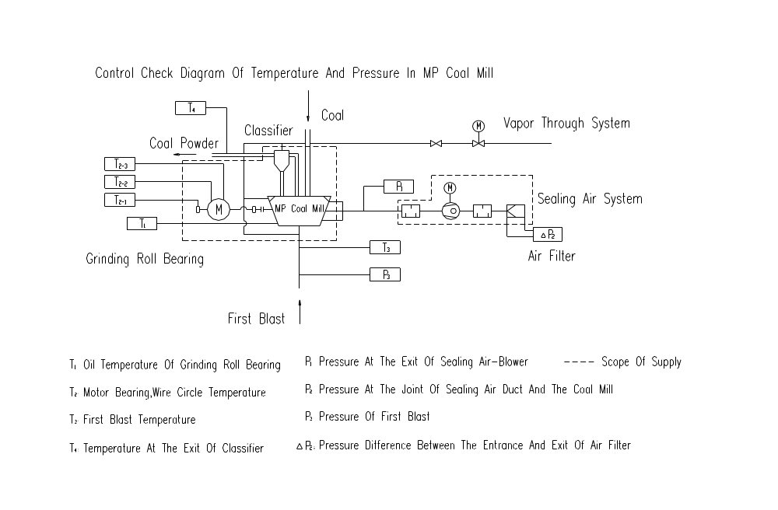
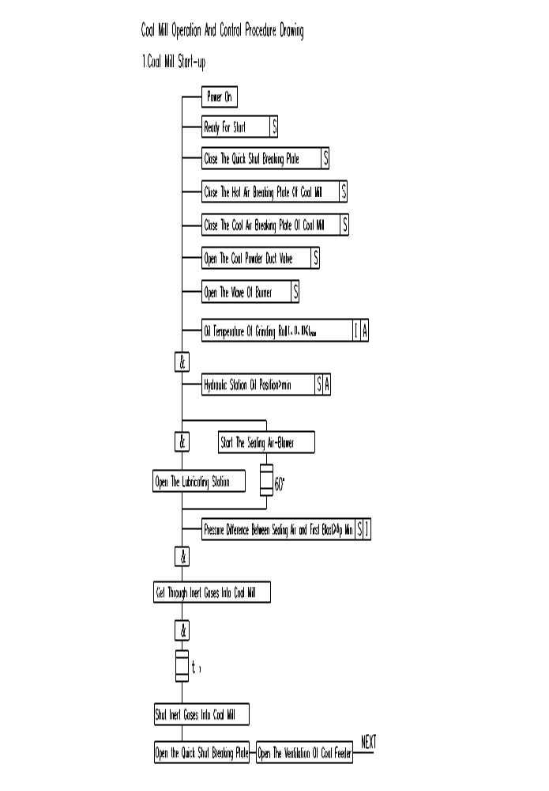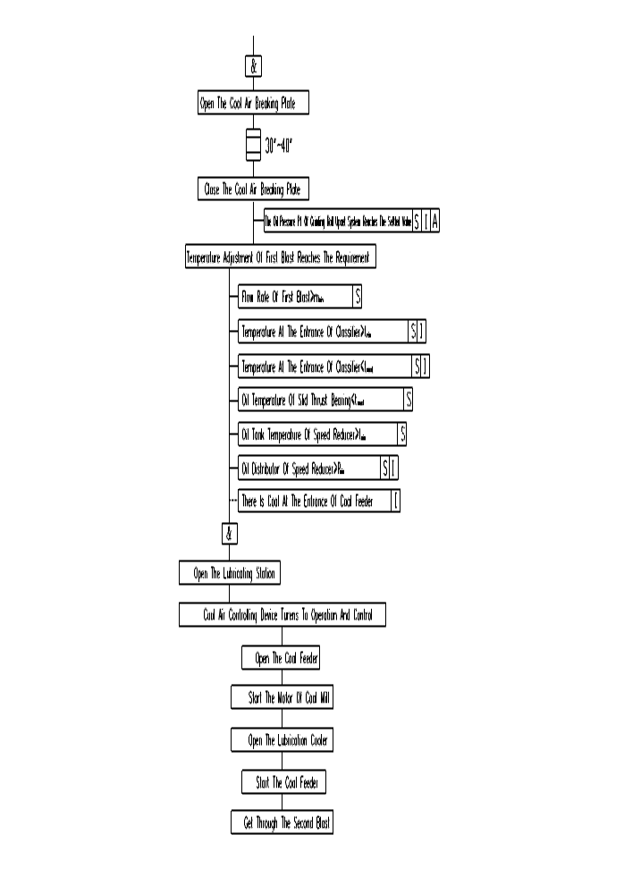
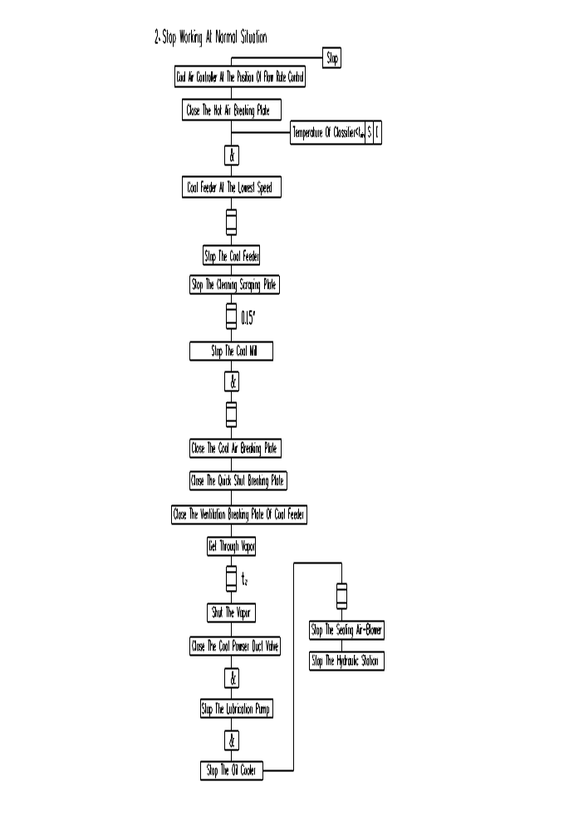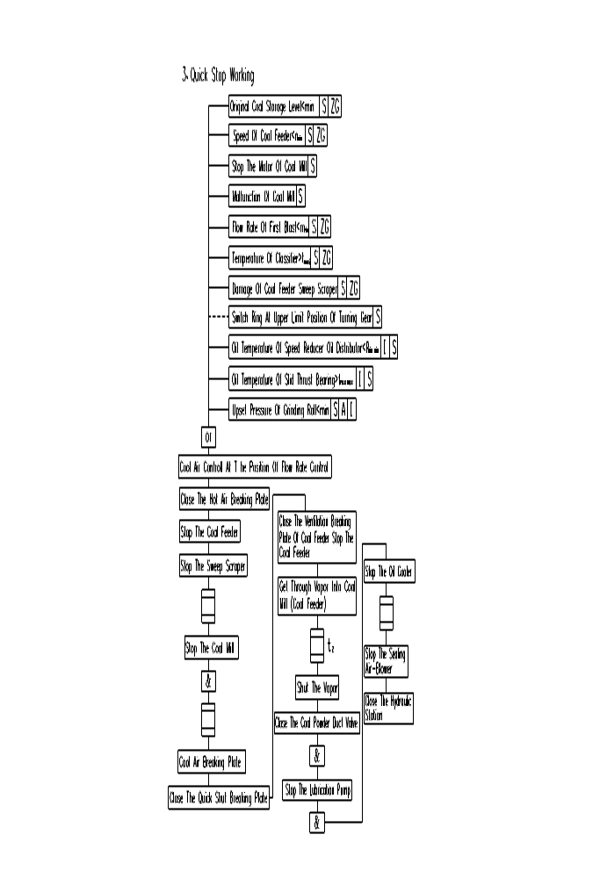

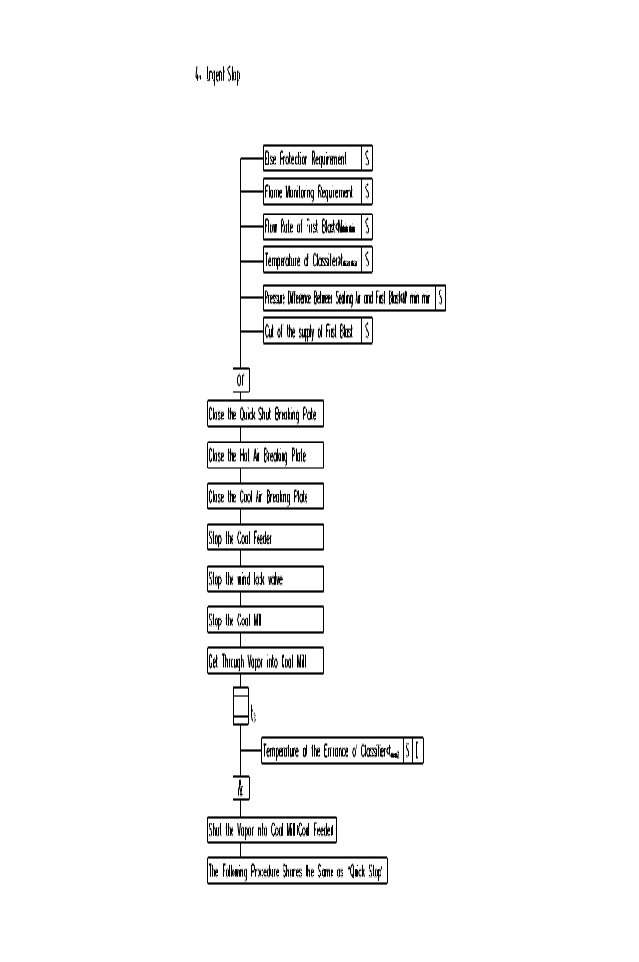
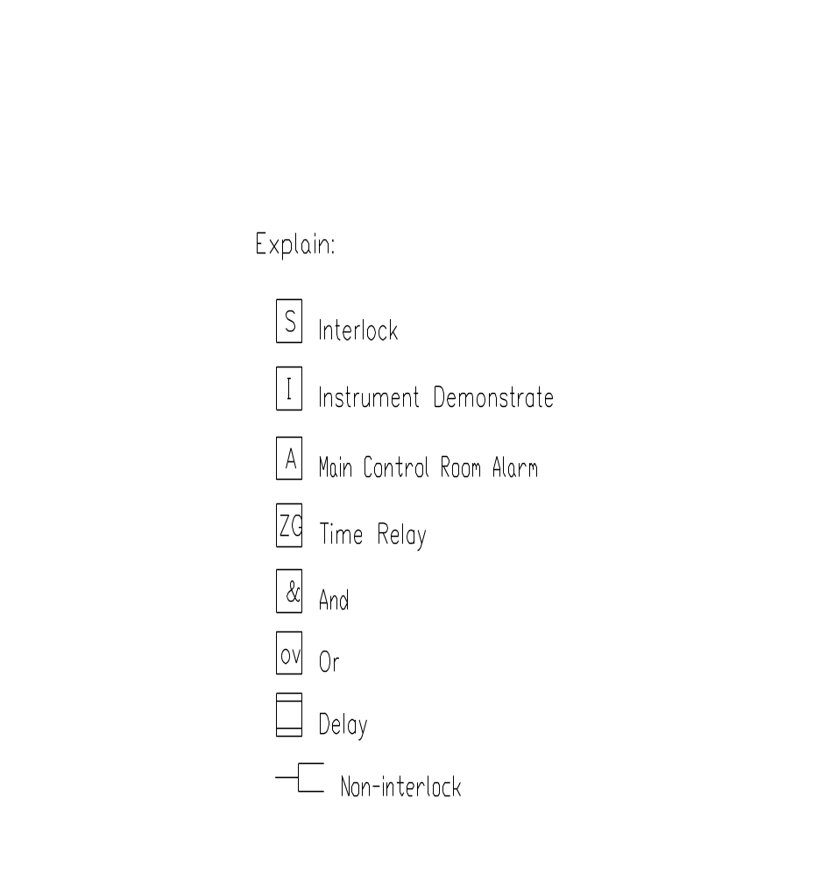
Limit value of classifier temperature
- t max. max = t running ＋ 30℃
- t maz = running ＋ 20℃
- t maxl = t running ＋ 10℃
- t running = f ( fugacity proportion of coal)
- t mln = 65℃
- t mln mln =60℃
Limit value of speed reducer
I. Oil temperature in speed reducer oil tank
- t max = 28℃
- t mln = 25℃
- t mln mln =25℃ (giving alarm)
II. Oil pit temperature of slide thrust bearing
- t max max = 70℃
- t maxz = 60℃ (giving alarm)
- t maxl = 50℃
- t mln = 35℃
III. Oil distributor of speed reducer
- Pmln = 0.15Mpa (oil pump at high speed gear)
- Pmln mln = 0.1Mpa

B.2.0 speed reducer of MPF coal mill

B.2.1 preparations for start-up
- Desiccant bag
Remove the desiccant bag in the reducer and the adhesive tape on the transmission shaft.
- Infusing lubrication
Infuse speed reducer with the set amount of lubrication. When the pump is working, the lubrication should overflow from slide thrust bearing pressure relief place, or the lubrication should reach the central position of the observing hole at the bottom of speed reducer. In these cases the amount of lubrication is right.
It shall use lubrication station to add lubrication, so the new lubrication can enter speed reducer through the filter. When adding lubrication, remove the flange cover of the pump oil absorbing side oil inlet. Fix in the right connecting flange (not provided). Then close the valve of absorbing pipeline. Put the lubrication in the pump through the new lubrication entrance. Run the pump to transport the lubrication to the speed reducer. To prevent the lubrication filter from over-pressure, the temperature of the new lubrication should be higher than 20℃.
When the lubrication is transported by the vehicle with a pump, the moving oil supply pipe should be connected to the new lubrication sprue. Follow the instructions above. For the first time, we must infuse lubrication, and there shouldn’t be other things in the reducer.
- Screw rod pump
The lubrication pump should only move according to the arrowhead.
Before starting the pump motor, check the circumrotating direction.
In the factory, the flooding valve was adjusted to 0.6Mpa (6 bar). This value should not be changed without permission.
- Oil filter
The oil filter has a three position four way commutation valve.
Middle position---- two filters work together.
Left position----Filter I on

Filter II off
Right position----Filter I off
Filter II on
When adding oil or starting coal mill, it should use the middle position.
After the reducer has worked for two hours, we can choose either filter to work.
- Ventilation
The air in the pressure oil system and pressure-measuring pipeline can cause trouble. So the pressure oil system should let off air. There should be a vent in the heater, filter, oil cooler and the pressure gauge.

B.2.2.Preparations of restart after stop
The preconditions of restarting speed reducer include that the reducer has enough lubrication and every lubricating place has enough lubrication. Therefore, we should keep preparing for restarting all the time. At this time the temperature of the lubrication should be higher than the lowest temperature, and lower than the highest temperature.
The following data is for reference in the first adjustment:
The temperature of lubrication cylinder: 25℃ min.
The temperature of lubrication in reducer: 28℃ max.
The oil pit lubrication temperature of slide thrust bearing: 50℃ max.
Before starting we should inspect all the mechanical, electronic, programmable, checking component. And they should be operated by professional operators.

B.2.3.Speed reducer operation
After the first start of the reducer, it should check its operation. Pay attention to noise, oil temperature, oil pressure and the sealing condition, etc.
The gears inside the reducer can be worn even if in a good condition. The metal waste can stay in the filter. So during the trial run, it should check and clean the filter from time to time to know its condition. At the same time we can measure and record the amount of metal waste. Before changing oil for the first time, it should check the filter every 50 hours. Later, it needs only check the pressure difference. The allowed difference is 0.1Mpa (1.0 bar)

B.2.4 Inspection when stop
When coal mill stops for a long time, it should stop the lubricating station and make an inspection. Every time while changing the oil, it should check the inside of the reducer, and pay attention to the worn condition of the bearing and gear surface. Only professionals and the experienced people can repair the reducer.

B.2.5 Technical data
1. The technical data when the mill stops (combine control)
The temperature of oil tank ℃ <25
The oil pit temperature of slide thrust bearing ℃ >50
The rotating speed of oil pump motor min 25
2. The technical data when the mill stops (non combine control)
The temperature of oil tank ℃ >28
The oil pit temperature of slide thrust bearing ℃ <50
  - Instructions of MPF coal mill repair and maintenance
C.1.0 Coal mill and static classifier
When the powder-making equipment is being operated, repaired and checked, it should abide by the related safety regulations.
It is not allowed to cut off any safety device，electric interlock device or detonation suppressor device and make them not useful completely or partly.
While repairing the coal mill, pay attention to the following points:
Cut off the power supply of the main transmission motor.
Close the breaking plate of first blast duct in the front of coal mill.
Close the valve leading to burner coal powder duct.
Close the manual valve of coal mill and the coal feeder on the vapor enter duct.
The coal feeder shouldn’t be on operation.
While welding, take potential protection measures to avoid the damage of the slide bearing and the gear when electrical current passes by.
Take notes on the above work.
C.1.2 Coal mill care and service when stops
Summary:
To ensure that the coal mill is very reliable and useful, there must be some time for coal mill to have a rest, during which time we take necessary repairs and changes of some components according to the plan, so that the coal mill can keep a good working state. Therefore, as for the maintenance work, we suggest taking precautionary measures rather than do it when it is necessary, so that the coal mill is very reliable all the time, and will not stop suddenly for operation.
The oil change of coal mill:
Change the lubrication when coal mill is not at work, and do it according to the lubrication list (see C.1.10). The cycle of changing oil on the list is only for reference. In actual operation, it is suggested that while changing the oil for the first time, make an analysis of the lubrication components and check the viscosity and the integrative index. During the operation, check the impurity of the lubrication during short intervals.
The discharge of the old oil:
The discharge of the old oil is carried on by one of the three bolt stuffs fixed on the grinding hub facing the coal mill center. While discharging the old oil, we should discharge at the same time the old oil in the columnar roller bearing and columnar roller aligning bearing. Please make sure not to remove the sealing cover to discharge the lubrication in the grinding hub. Before discharge the lubrication, use the turning gear to move an oil-discharging bolt to the lowest place. The discharged old oil should be put to a proper container.
After discharging the old oil, screw down the bolt and lock it with clamp ring from becoming less tightened.
The infuse of new oil:
Infuse oil following these steps:
Open the inspection door of the intermediate housing of coal mill.
Remove the guard cover of measuring thermal resistance.
Remove the bolt stuff on the screw hole for measuring oil level on the grinding shaft.
Heat up the new oil to about 50℃ (suggested by lubrication supplier) to improve its fluidity.
Use proper tools (such as a funnel or a hand-feed pump) to infuse new oil from the outside of coal mill through the inspection door to the screw. Pay attention that the exhaust is OK (change the exhaust filter bolt if necessary).
The amount of infused oil is controlled by oil level hole, and stop at the highest oil level.
After taking out the oil level hole, screw down the bolt of the oil-measuring screw.
Put on the guard cover of the temperature-measuring components and the sealing pad.
Close the inspection door of the intermediate housing.
Repeat the above operations to fill the other two bearing with oil.
The inspection of the milling components:
The working surface of the grinding rolls skin and grinding track liner may be worn which may change the shape of them. Therefore, when the mill is not at work, we should check their wearing state. In this way we can get their net wear，and so we can get the curve of the relationship between its unit consumption and the given worn and the contribution.
We recommend using the template to check the wearing state of the grinding components. The templates for measuring the grinding roll skin and grinding track liner is shown in Picture 7.8 (the thickness of wooden template is 1.2mm and that of the steel plate is 1.5mm).
The measuring of the wearing state of grinding track liner should be carried on at the three proportionally distributed points on the grinding track circle. While measuring, clean the measuring place. Put the templates on and get the related data according to the measuring position on the template.
The measuring of roll skin should measure the related two points on the circle.
Measure the wearing state when the mill works for 500-1000hours. The result can help us predict the lifespan of the components and make compares of the efficiency, so that we can make plans on time. In order to get a reliable record, we should use a form to record the data.
According to the influence from various unpredictable factors, the wear and rupture of the milling components cannot be achieved by the qualitative and quantitative calculation. And we cannot make judgments from studying the situation.
Therefore, the lifespan of the milling components can only be predicted after measuring the wearing quantity, the powder grinding fineness, the contribution, the reliability of operation, the utilization rate, the fatalness of the accident, the cost of time and money.
As for the limits because of the hardness of the materials, the utilization rate of the milling components is limited. We suggest that when the thickness is 10mm, we should discard it as useless.
The milling parts of the mill is made from nickel and chrome alloy. It is a very hard material, which is fit for the temperature as high as 500℃. But this material is very sensitive to the sharp change of temperature. So we mustn’t cool it with cold water or compressed air when the mill has just stopped.
In addition, any immature techniques cannot be applied to this material. Ni-hard IV is very sensitive to this.
Generally speaking, because of the welding method the Ni-hard IV will be reduced the ability of anti-high temperature and has cracks. So it is not recommended to use welding method here.
Attentions:
New roll skin or the reversed roll skin must be used together with the new grinding track liner.
After the grinding parts are renovated, we must check all the tightening bolts on the grinding track after a short time of operation. Tighten the screws if necessary.
The check of inside coal mill:
The check wearing state of the mill inside is also a part of the inspection when the mill is not at work. The inspection includes:
scraper，spray nozzle ring，tie rod tightening device, inner liner of intermediate housing, guard plate on grinding roll bracket, guard hood of the grinding track, the sealing air duct, the compression plate, oriented device, classifier, joint bearing of the mill sealing air duct.
As the operating time of the mill accumulates, the intervals of the compression plate and intermediate housing limit plate will increase. This will cause the unstable operation of the mill. So every time we check the inside of the mill, we should check this interval and make a record. When this interval becomes twice as much as that on the blueprint, we should put a pad with the corresponding thickness (made from steel plate). This pad should be designed in the form that we can push it up from the bottom.
If there is step wear on the limit plate, the move of compression plate will be influenced. At this time we should change the limit plate.
Another important checking work is on the wearing, tightening state of the sealing air duct and whether joint bearing has trouble in moving freely.
The movable breaking plate in the classifier should always be cooperative and very flexible to prevent the air from refluence. The hanging fibers can be eliminated through the entrance hole on the classifier. The bearing on the breaking plate and the corresponding mechanical parts should use M_{o}S₂ lubricating grease.
The welding of the mill
Around the welding place, we should take potential protection measures, to avoid the damage of the components such as slide bearing caused by the electric current.
C.1.2.1 Inspection of inside coal mill (grinding cavity)
Coal mill driving motor
Before open coal mill inspection door, cut off the electrical wire of the main driving motor.
Coal feeder
Make sure that the switch of the coal feeder is turned off.
Turning gear
Detach the turning gear and the main motor.
First blast duct
Before open coal mill door, check whether the breaking plate on the first blast duct is closed.
Steam enter system
Close the manual valve of the steam duct in the middle of coal mill.
Open coal mill door
Attentions: be careful while opening the door. The heat may be dangerous to people.
The cleaning of inside coal mill
Check whether there are installing tools, waste, large pieces, cloth, fibre or other waste inside of coal mill (grinding cavity, hot air room and the classifier). If there are, lean them out.
Spray nozzle ring
Clean the intervals between the spray nozzle ring and the grinding track, otherwise there will be noise when coal mill is at work, which will cause unnecessary misunderstanding.
The grinding roll
Check the oil level of the grinding rolls with an oil level hole. If we need to infuse the new oil, check if the oil-discharging bolt is tightened. Close all the inspection hole cover. The quality of lubrication should conform to the standard.
Compression plate
Check to ensure that the compression plate can move freely vertically. Check the intervals between the limit plates.
Classifier
Check whether the waste-discharge breaking plate can move freely.
The grinding door
Close and lock the grinding door.
Coal mill driving motor
Connect the coal mill driving motor and check its rotary direction.
Attentions: Never start the main motor when there is no grinding materiel.
Pay attention to the intervals before two starts.
Steam enter system
Open the manual valve of the steam duct in the middle of coal mill.
Waste discharging
During the first period of operation, check it at least once every 2 hours. Check more often if necessary. The length of the period depends on the amount of the waste. Wastes lies on the quality of the materiel, the output of coal mill and the operating mode of coal mill.
In addition, the waste is also influenced by the speed of wind at the exit of spray nozzle ring. By increasing the speed of wind at the exit of spray nozzle ring we can reduce the amount of the waste, but it can wear the components. The speed of wind at the exit of spray nozzle ring can be adjusted by changing the section area of the exit.
After testing the operation of coal mill, we can partly cover the spray nozzle ring wind-outlet hole to achieve a good balance of coal mill output, wearing and the waste.
When the mill starts or stops, the increase of waste amount is normal.
As the first blast duct doesn’t have ability to reserve the waste, it is not allowed to operate the coal mill for a long time with dregs-discharge system closed.
C.1.2.2 Inspection of outside coal mill
Coal mill sealing air
Check the operating state of coal mill.
Check the sealing air distributing system according to the butterfly valve opening degree at the sealing air exit. 50% should be given to grinding rolls, 45% to the bottom housing and the 5% to the tie rod to seal.
Make sure that the three grinding rolls and the sealing ring of bottom housing provide enough clean sealing air. Because of this, we must distribute properly the sealing air provided by the sealing air-blower. This is finished by butterfly valve on the way to the sealing ring of bottom housing. The sealing air is distributed properly. As long as the sealing air is discharged from the interval of the joint bearing of the three grinding rolls sealing air duct and the sealing ring of bottom housing, the dust will be prevented from entering the sealing air system.
When coal mill is operating, the pressure difference of the sealing air and the on-off air should be higher than the certain value, and it should never be lower than the needed pressure difference.
The hydraulic station:
The check and maintenance of hydraulic system should follow the instructions of the manufacturer.
The grinding pressure:
The grinding pressure is controlled by the valve in the hydraulic station. After the grinding parts are worn, there is no need to adjust the pressure. The adjustment can be carried on during operation. The adjustment should be carried on slowly. Never surpass the max grinding pressure.
The measuring device
The measuring device can only be adjusted when coal mill stops or when there is no materiel in the grinding parts. We can get to know the following things with this device:
The wearing consumption of the grinding roll skin and grinding track liner.
The change of thickness of the coal level
Before using the measuring device, we should adjust it. Put the point on the measuring ring of the tie rod to the zero of the surveyor’s rod and then tighten it. When coal mill is working, put some coal between the grinding rolls and the grinding track and raise the tie rod. The measuring ring raise with the rod. Put central scale of the level of coal on the surveyor’s rod to the point of measuring ring, and then we can see the thickness of the coal level and its changes. And we can also estimate the degree of wearing.
When there is no materiel in coal mill, we can see the approximation of degree of wearing from the surveyor’s rod.
The classifier
Adjust the breaking plate of classifier. During the first operation, adjust the breaking plate to 40% opening degree.
Steam enter device
Make the duct of Steam enter device a good working state. Check the steam pressure and temperature of air-inlet end of the electric cut-off valve. Open the manual cut-off valve of the steam air-inlet end duct when coal mill is working.
C.1.3 Assembly and disassembly of grinding parts and parts inside coal mill
The work of assembly and disassembly of grinding parts and the parts inside coal mill are generally done vertically.
Therefore, remove the powder outlet pipe with a telescopic joint in the front of the classifier, and remove the classifier with a lifting apparatus. So the user should have all sorts of slings, chains and other tools for slinging to remove and install the grinding track, the grinding track carrier, the compression plate and the grinding rolls. Their weight is in D 32.
C.1.3.1 Speed reducer
Special tools should help the disassembly of speed reducer. The disassembly direction is the direction of the motor. The procedures are as follows:
- Release the pressure of the tie rod.
- Remove the four covering boards of the bottom housing. Rotate the supporting arm on the grinding track carrier to the four holes on the bottom housing with the turning gear.
- After removing the cover plate on the grinding track, remove the connecting bolts of the grinding track and the reducer flange.
- Release the lubrication in speed reducer and the slide thrust bearing. Remove the oil duct and the electric wires.
- Remove coupling protecting cover.
- Remove the coupling.
- Remove coal mill driving motor and turning gear.
- Remove the motor bed.
- Put the mill carry-up device on the reducer carrier.
- Put the hydraulic cylinder in the mill carry-up device.
- Raise the grinding track until the adjusting pin is in carry-up device and install the safety pin.
- Remove the fixing plate between the reducer and motor. Find the bolt of the rotating reducer.
- Carry-up the reducer with the hydraulic tank. Put some lubrication grease under the reducer and the gliding track and put it down. Pull the reducer out of the bottom housing with the hand-operating telpher at the end of the pulling track.
- The removed reducer should be put on the trailer to transport.
- Installation of speed reducer
Put the reducer back to its place in the bottom housing. Operate the hydraulic tank with the opposite procedures of removing the reducer. See details in the instructions of installing.
C.1.3.2 Disassembly and assembly of classifier
(Only fit for horizontal remove)
- Check whether the classifier-removing device is all ready. It includes four rolling implement fixed by bolts, four hydraulic jacks, two set of hand-operating telpher and all kinds of riggings.
- Lift the coal powder outlet pipe with rigging.
- Remove the connecting bolt of the classifier flange and the coal powder duct flange.
- Rise the expand joint (top of the classifier) to where the classifier can move out.
- Remove the connecting bolt of the classifier and the intermediate housing.
- Remove the connecting flange of the steam duct.
- Remove the connection with the sealing air duct. If necessary, remove the pipeline.
- Remove the vertical sealing air duct leasing to the grinding rolls.
- Carry-up the classifier 20-50mm with the hydraulic tank and the manual pump. Take away the hydraulic tank and install the hand-operating telpher and the riggings. The classifier leaves completely through the grinding cavity and then lock it.
- The installing of the classifier is carried on in the opposite order.
C.1.3.3 Disassembly and assembly of compression plate
- Make marks on the compression plate.
- When installing the supporting device of the grinding rolls, avoid their falling down.
- Remove the bolts on the suspension device of the compression plate.
- Get through steel wire or steel chains at the suspension device, and lift them.
- Remove the connecting plate between the compression plate and the roll bracket.
- Remove the hold-down plate on the crossbeam of the tie rod.
- Raise the tie rod to the highest place with the hydraulic cylinder.
- Remove the connecting crossbeam and steel ball between the tie rod and compression plate.
- Lift the compression plate and put it to a suitable place.
- The installation of the compression plate follows the opposite order. Pay attention to the clearance between the compression plate and intermediate housing.
C.1.3.4 Disassembly and assembly of grinding roll (lift directly from the intermediate housing)
- Remove the joint bearing on top of the grinding rolls.
- Put on the lifting apparatus for the grinding rolls.
- Lift the grinding rolls slightly.
- Raise, move and put down the grinding rolls.
- Remove other the grinding rolls with the same order. It is opposite when installing the grinding rolls.
C.1.3.5 Disassembly and assembly of grinding track.
- Make marks on grinding track cover. Remove the bolts on it and lift them away.
- Mark the installing position of the grinding track.
- Put the suspension loop bolt on the three lug bands of grinding track.
- Lift the grinding track and put it to the right place.
- Opposite when installing the grinding track.
C.1.4 Repair of coal mil components
The repair of coal mill components should be carried on in the suitable workshop with the suitable tools by competent people.
C.1.4.1 Speed reducer
The reducer should be repaired partly following the instructions. If necessary, invite the people from the manufacturer to repair.
The change of the welding gear should be done by the manufacturer.
C.1.4.2 Grinding rolls
1. General rules
The disassembly and the assembly of grinding rolls should be carried at clean place.
The new roll skin and grinding track liner should not be welded, because this will make the components shatter or even abate.
Cool the grinding rolls which has just been removed from coal mill to the same temperature as the outside. This should be followed at any time. As the heat in coal mill dissipate slowly, the cooling process needs at least 24 hours. To avoid damaging the bearing, it should not cool the roll skin with the compressed air.
2.Release of lubrication before repairing the grinding rolls
When coal mill needs unloading, release the oil with the operating temperature. After that, lift the grinding rolls, wind one of the 3 bolts to the lowest place. Discharge the oil to the right container, and keep the sample of the oil for further analysis.
3. Remove of roll skin
Remove the breaking ring of roll skin, and then remove the roll skin with the grinding rolls removing device.
If the roll skin is not flexible, take away the grinding rolls removing device. Heat up the outside of the roll skin. During the heating process, the heating nozzle should only heat the outer ring. The distance of the nozzle and roll skin should be 100 to 150mm.
Attentions: Never use gas-welding gun to heat because it is not stable and too hot. It will reduce the rigidity of the material or even make the roll skin useless because the Ni- hard is sensitive to heat.
During operation, the channel of the roll skin may accumulate coal powder. Be careful when heating the roll skin.
Heat up to 50℃ (check with the color-changing chalk or the touching thermometer). Keep the temperature for 15 minutes. The temperature changing rate should be less than 0.5℃/m/n.
Remove the roll skin with the grinding rolls removing device. In most cases, the roll skin is flexible. If it still doesn’t work, heat again and raise 10℃ of the temperature. Raise the temperature difference of the two fittings.
- Disassembly of roll bracket
The work should be done as follows:
Put the grinding rolls with the grinding rolls on the shelf.
Remove the guard cover of the temperature-measuring components.
Remove the temperature-measuring components and the discharging bolt.
Remove the hold-down plate at the side of the shaft.
Remove the protecting bolts at the outside of the bracket.
Take out the bracket with the grinding rolls removing device. Use the heating method if necessary.
Lift away the bracket with the bolt of suspension loop.
Attentions: Before removing, check the intervals between the sealing air and the rotary sealing ring. If the radial clearance is more than 1mm, change the new sealing ring.
5. Disassembly of grinding rolls bearing
Remove the fixing bolt on the bearing cover.
Remove the bearing cover.
Remove the sealing ring and the O-shape ring with the steel-protecting ring.
Remove the hold-down ring which fixing the columnar rolls bearing inner ring.
Adjust the position of the grinding rolls and make the axial end down.
Remove the bearing cover and the O-shape ring from the hub of the grinding rolls.
Remove the axial end hold-down plate of the spherical rolls bearing.
At this time remove the shaft with the grinding rolls removing device.
Remove the inner ring of the columnar rolls bearing from the shaft.
Remove the bolt in the hub. Connect the high-pressure oil pump and instill the high-pressure oil.
Remove the spherical columnar rolls bearing.
Remove the outer ring of the spherical columnar rolls bearing.
By then all the components in the grinding rolls are removed. We can clean them now.
- Inspection of the grinding rolls bearing
It is generally considered that the wearing only occurs on the mutually gliding parts. Actually the slide bearing will also be worn as the rolling parts makes the materials fatigue. The lifespan of the slide bearing will be influenced by the damage of rolling parts.
During the checking, we should check the wearing, grinding, waste, canker, cracks, distortion, and the size of the outer and inner ring of the columnar rolls bearing, the spherical columnar rolls bearing, the rolls and the protecting ring, etc.
Change the bearing cover and the O-shape ring if necessary, in order to keep a good sealing condition.
The surface of the rotating parts should not have grinding, waste, canker and other damages, other wise it may cause leakage. But a slight leakage of the sealing ring is better than not, because the heat produced by friction may cause the sealing parts aging. The checking items should include the diameter, circular degree, columnar degree and the cleaning degree of the sealing ring. It is the condition that the sealing effect can be performed well that these items are normal.
- Installation of grinding rolls bearing
Make some adjustment to the bearing before installation. The installing place should be clean and the connecting parts should be precise. As the function and the reliability all depend on whether it is correctly installed, this work should be carried on by experienced workers.
While installing the bearing, the inner ring of the columnar rolls bearing should be put into the oil and heat up to 80℃. The highest is 90℃. And then let it glide into the grinding shaft and be cooled naturally.
Fix the inner ring of the columnar rolls bearing with the shaft end board.
Lift the grinding hub; the side of e spherical columnar rolls bearing is up. Heat up to about 100℃. The time is 1 hour and 30minutes.
Put the spherical columnar rolls bearing to the hub.
Put in 2 flat irons. Avoid the move of spherical columnar rolls bearing. But it shouldn’t intervene the install of grinding shaft.
Adjust the direction. The side of columnar rolls bearing is up.
Put the outer ring of columnar rolls bearing and the grinding bracket in the grinding hub, which is still hot.
Put the grinding wheels and the already fixed inner ring of columnar rolls bearing to the hub.
Use the axial pressing cover to tighten the spherical columnar rolls bearing axially.
Cool the well-assembled hub.
Check whether the bearing can move freely.
Use the sealing mat and bolts to seal the high-pressure oil entrance at one side of columnar rolls bearing.
Heat the sealing with the bush to 90℃ and then put it in the grinding shaft. Put the O-shape ring in before the bush.
Put the O-shape ring to the groove of the hub. If necessary, fix it with glue.
The reliability of the bearing mainly depends on its ability to anti water and dust and the prevention of lubrication leakage. The quality has great influence on the lifespan of the bearing. In the two sealing rings in the sealing bearing cavity can avoid leakage. The outer ring avoids the air, water and dust. So while installing, look carefully at the blueprint. The sealing lip must always face the side that needs sealing.
Inner sealing ring: the sealing lip faces the rolls.
Outer sealing ring: the sealing lip faces the bracket.
Embed the supporting ring and install the outer sealing ring following the above order, and use flange and the inner turret bolt to fix it to the cover. Avoid the axial move. The supporting ring is used for supporting the sealing ring and the sealing lip.
Put the installing ring for cover to the grinding shaft and make the prick shape outside.
Put the lubrication grease to the installing ring and the bush.
Make the well-fixed glide into the wheel carefully and fix it on the hub. Don’t destroy the sealing lip.
Remove the installing ring and keep it well for use.
Put the sealing air sealing ring on and fix it.
Adjust the direction. Make sure that the spherical columnar roll bearing is up.
Remove the flat iron on the spherical columnar rolls bearing.
Instill the high-pressure oil and seal it with sealing mat and bolt.
Embed the O-shape ring to the cover groove.
Put the cover to the hub. Use the bolt and clamp washer to fix and lock. The screw moment of the bolt is 400N.m.
Then seal all the openings. Check the sealing capability with the compressed air. The compressed air should only be clean and dry air.
While trying the pressure, install the inverted valve, pressure reducing valve and the pressure gauge compressed air pipeline to the oil level measuring hole. Use the pressure 0.2Mpa( 2 bar) to instill air to the bearing cavity, and then closer the inverted valve. The pressure should reduce to less than 0.1Mpa (1 bar) after 30minutes.
- Installation of roll skin of grinding rolls
While installing the roll skin, there should be enough temperature difference. In most cases, 5-15℃ is enough. This can be got from the remnants of different tempering furnace.
Put one side of the spherical columnar roll bearing up.
Lift the roll skin.
After making sure that the roll skin is level, glide it quickly to the hub.
Pat attention to the suitable position of clamp rabbet.
When the shoulder of the roll skin is level with the hub, remove the lifting apparatus.
Install and fix the roll skin hold-down flange.
Lift the grinding rolls and overturn 180 degrees. The side of bracket is up.
Tighten the roll skin thrust piece and lock it with clamp washer.
Finally install the flat wearing-protection ring.
- Installation of grinding bracket
The grinding rolls are as the above position.
Remove three bolts at the outside of the bracket used for transporting.
Wind the suitable suspension loop bolt to the screw hole.
Lift the bracket to the level position.
Heat up the bracket to about 100℃.
Put the gliding key to the key groove.
Glide quickly the bracket to the shaft. When the shoulder is on the bush, the gliding process is over.
Install the axial end breaking plate.
Remove the lift, and put in the bolt again on the transporting screw. Attention: Never use this swinging ring to transport all the grinding rolls.
Clean the air filter, and install it on the grinding shaft.
Install the temperature-measuring device.
Install the guard cover.
Check whether the grinding roll is flexible and even.
Install the wear-resisting liner on the bracket.
The grinding rolls should be put to the dry room. If leaving it alone for a long time, we should take measures to prevent from rust. When using lubrication to antisepticise, pay attention to the dissolubility of antiseptic.
- Change of grinding track liner
Unload of the grinding track liner:
Remove the clamp bolt, and the remove the nut, washer, butterfly spring and O-shape ring.
Remove the protecting ring of the upper part.
Remove bolts on the three screw-fixing holes. Prepare for removing the first
liner of grinding track.
Put the corresponding to the related screw. Lift up the first grinding track.
Use the special lift and take the first liner away
Loosen all the rest liner and lift the away one by one.
Clean and check the grinding mill.
The install of grinding track liner:
Use the special lift and take the first liner to the grinding track, and make it move anticlockwise to touch the stopping pin.
Fix with tightening bolt grinding track liner. The tightened moment of tightening bolt is 200N.m.
The nut, washer, butterfly spring and O-shape ring should follow the instructions of the blueprint.
Install the rest grinding track liner. The side of each grinding track liner should touch each other. While installing the last grinding track liner, boss polish it or put steel plate in the intervals.
At assembly and fixing the grinding track, pay attention to its correct position and avoid turned-up and looseness, in case that crack or other accident will happen.
Fix guard ring on the grinding track.
Seal the three screw-fixing holes at the bottom part of grinding track with bolt and drive it tightly.

C. 1.5 Replacement Parts
In order to ensure a high rate of rotary of the coal mill, and shorten the stop working time at maintenance, it shall prepare enough parts of coal mill. In addition, it shall also add the consumption of these replacement parts. It’s advised that the fewest variety and amount of regular replacement parts shall be as below described:
6 suits of grinding roll, including roll carrier etc.
2 suits of grinding track with grinding track liner
6 pieces of roll skin
4 suits of grinding track liner
2 suits of roll carrier wear-resisting plate
6 suits of rolling bearing of grinding roll
6 suits of sealing ring on grinding roll
6 suits of sealing parts of tie rod hydraulic cylinder
6 suits of sealing air duct of grinding roll, including joint bearing
2 suits of spray nozzle ring as well as attachment

  - 1.6 Maintenance items of coal mill

No. | Description | Circle | Maintenance Item | Remark
1 | Collectivity | Running Period  - Running steadily  - Leakage  - Damage of parts  - Temperature, pressure and oil position  - Filter of hydraulic station and lubrication station | It shall often inspect to avoid the malfunction at the very beginning.
2 | Cleanup the scrap | Twice per shift | Inspection the working status of dregs cleanup system.
3 | Bolt | Before the 1st running  After 1st running for 20~30 hours, every 2000 hours | Inspection of bolt fixing situation | Only permit clamp at cold status of coal mill
4 | Grinding roll | After 1st running for 500 hours, every 1000 hours | 1.Inspections of grinding roll oil position.  2.Leakage of oil.  3.Roll skin surface wear and tear. | Only permit running at stop working
5 | Grinding track | After 1st running for 500 hours, every 1000 hours | - Fixing status of grinding roll liner.  - Wear and damage of grinding roll liner.  - If there is any eyewinker.
6 | Sealing Air duct  - Outside  - Inside | After 1st running for 500 hours, every 1000 hours | 1.Open and shut of adjusting valve.  2.Wear and tear of inner pipe and the flexibility of joint bearing. | It shall change the pipe when thickness of pipe is lower than 1.5mm.
7 | Nozzle ring | 2000 hours | Check if there is any eyewinker and wear.
8 | Grinding roll scraper | 2000 hours | Check the wear and tear situation, and the flexibility.
9 | Intermediate housing liner | 2000hours | Check the wear and tear situation. | It shall change a new one when the thickness is lower than 1mm.
10 | Oriented Plate | 2000hours | 1.Inspection of wear and tear, and avoid malfunction.  2.Step shape wearing.  3.Clearance.
11 | Ring-shape bolt、circle seat、ball beam | 2000hours | 1.Assembling position  2.Wear and tear situation  3.Fastness
12 | Tie rod joint bearing | 2000hours | Flexibility and Wear and tear situation
13 | Tie rod sealing telescopic joint | 500 hours | Sealing situation
14 | Hydraulic station | 1.The performance at the 1st running.  2.Lasting running for 100 hours  3.Every 500 hours | 1.Check the performance of sealing  2.Check and wash the filter  3.Check the oil position  Check the clearness of oil  4.Oil temperature
15 | Hydraulic station and liquid of tension device | - After 1st running  - 1st running for 100 hours  - Every 500 hours | Check the pressure and leakage of gas storager
16 | Guard device | Before each running | Check the working performance
17 | Hydraulic oil | Each year | Replacement; if the oil is dirty, it shall clean the equipment, cleanup the resid inside oil tank and filter.
18 | Collectivity | 2000 hours | Check all the electric switch and the function of interlock device

C.1.7 Coal Mill Malfunction causes and Treatment

No. | Malfunction/Signal | Causes | Treatment
1 | Pressure difference between first blast and sealing air becomes smaller. | - The filer at the entrance of sealing air-blower is blocked.  - The position of sealing air duct breaking plate is wrong.  - The sealing air duct is leaking or damaged.  - The sealing parts in grinding roll, tie rod or bottom housing are invalid.  - The malfunction of sealing air-blower. | 1.Stop the coal mill, clean the filter and 2.Adjust the breaking plate to correct position.  3.Repair or Replace  - 〃  5.Avoid the malfunction
2 | The temperature of classifier too low/high while running. | Malfunction of the controlling device of first blast temperature | Chang the controlling of first blast to temperature to man-control, and avoid the malfunction of controlling device.
3 | The temperature of classifier increases very fast. | - The failure of first blast control  - Catch fire inside the coal mill  The temperature of classifier≥110℃ | - Idem  - Urgent stop the coal mill and get through the vapor until the temperature falls down.
4 | The oil position of grinding roll is too low. | The sealing parts are invalid. | Stop working, repair or change the sealing parts, add oil to prescriptive oil position.
5 | The oil temperature of grinding roll is too high. | - The oil position is low.  - The bearing is damaged.  - Malfunction or wear up of the sealing air duct. | See item No.4  Stop working; change grinding roll bearing, repair or change.
6 | The running is abnormal. (Abnormal noise). | - There is eyewrinker between milling parts.  - The wear up of the milling parts.  - The wear up of oriented plate or too large clearance.  - The nitrogen in hydraulic cylinder energy accumulator is too little or the gasbag is damaged.  - There is no coal on the grinding track. | Stop working; clean out the eyewrinker, check if there is damaged parts;  Attention: When there is high rigidity, such as iron piece, it shall clean out it or it will damage the milling parts.  Replace  Replace or adjust the clearance  Stop working and hydraulic station, filling gas to check the energy accumulator.  Coal falling pipe is blocked.
7 | The coal powder is too large. | - The first blast flow rate is too large.  - The milling pressure is too small.  - The damage of classifier vane.  - The wear up of classifier interior wimble.  - The hydraulic oil is too hot. | Adjust to suitable value  Adjust to suitable value  Replace  Change  Increase the volume of cooling water.
8 | The pressure difference of the two filters in hydraulic station is over the limit. | The filter is blocked. | Wash to clean
9 | The oil pressure in oil distributor is too low. | - The working of oil pump is abnormal.  - The front valve of oil pump is half opened.  - Double oil filter is blocked.  - The rear valve of oil pump is half opened.  - The oil supply pipe is blocked. | Check according to oil pump introduction  Open completely  Wash to clean  Open completely  dredge the pipe
10 | There is no or few oil at the slid thrust bearing | The pipeline inside the speed reducer is blocked. | 〃
11 | The temperature of lubrication is too low | The monitoring device for coal mill start-up is at the position of “stop”. | Check the heater, repair if necessary, but it shall not shut the cooler.
12 | There is noise from speed reducer. | - There is eyewrinker inside the speed reducer.  - The damage of bearing.  - The damage of gear.  - The damage of speed reducer coupling.  - The assembly of coupling is wrong. | Notify the manufacturer to deal with it.  〃  〃  Change the coupling  Position well the coupling
13 | Oil leakage. | - The damage of flange sealing parts.  - The looseness of connecting bolt. | Change new Sealing Parts.  Clamp firmly the flexible bolt

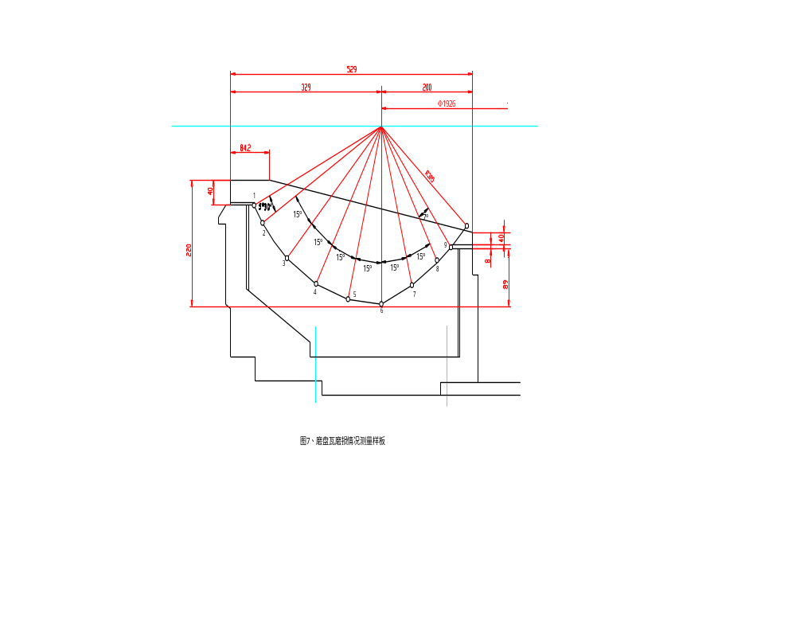

Record about the Wear Situation of Wear-resisting Parts

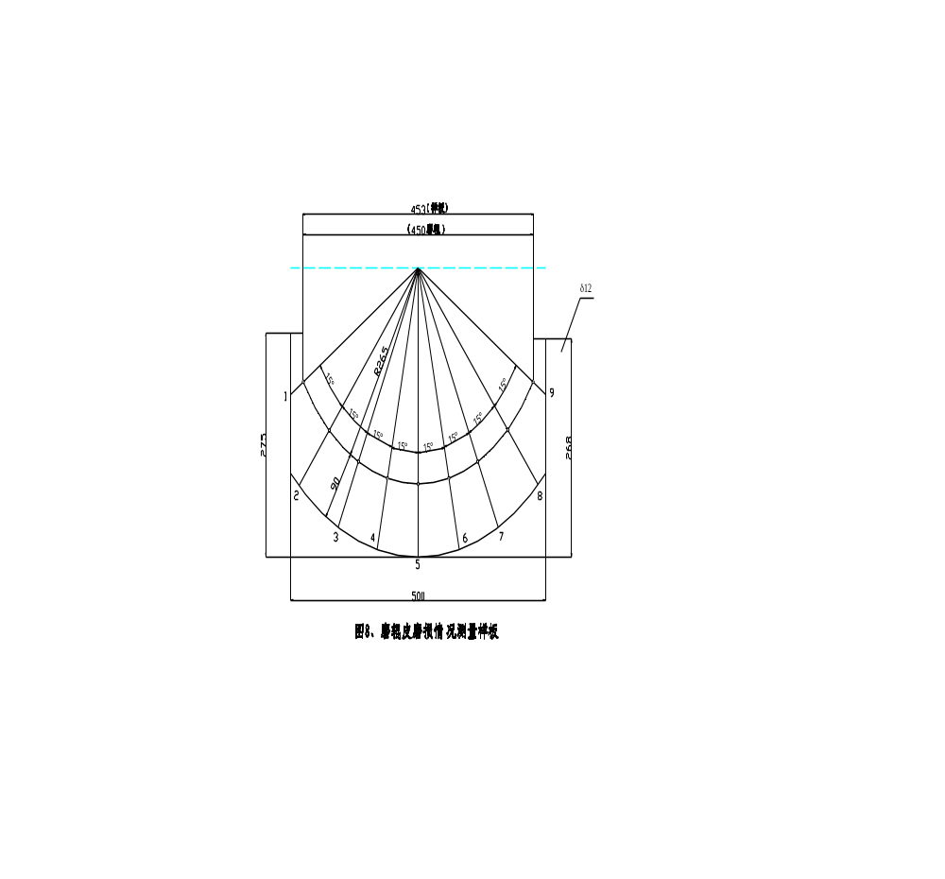

DATE | RUNNING HOUR |  | WEAR&TEAR | Damage Value at Measuring Point mm
 |  |  |  | 1 | 2 | 3 | 4 | 5 | 6 | 7 | 8 | 9
 |  | Grinding Roll Ⅰ | Min.
 |  | Grinding Roll Ⅰ | Max.
 |  | Grinding Roll Ⅰ | Average
 |  | Grinding Roll Ⅱ | Min.
 |  | Grinding Roll Ⅱ | Max.
 |  | Grinding Roll Ⅱ | Average
 |  | Grinding Roll Ⅲ | Min.
 |  | Grinding Roll Ⅲ | Max.
 |  | Grinding Roll Ⅲ | Average
 |  | Grinding Track Liner | Min.
 |  | Grinding Track Liner | Max.
 |  | Grinding Track Liner | Average
 |  |  | Milling Parts Remain Weight
 |  |  | Grinding Roll Ⅰ |  | Kg
 |  |  | Grinding Roll Ⅱ |  | Kg
 |  |  | Grinding Roll Ⅲ |  | Kg
 |  |  | Grinding Track Liner |  | kg

C.1.8.1 Preface
This hydraulic station is designed specially for the MP coal mill. It has the following functions: Adding pressure to the grinding rolls. Lift up and put down the grinding rolls. The whole set of hydraulic device has driving motors, safety and controlling device, the hydraulic tank with accumulator, safety valve, the lifting mill or compression plate.
The grinding pressure needed by the grinding rolls is provided by hydraulic system. The compression system includes 3 hydraulic tanks and accumulator. There is rubber air chamber in the accumulator filled with nitrogen. The oil-infusing side of the accumulator is directly connected with the side of the piston rod, the overflowing valve and the oil-providing pipelines. The three hydraulic tanks are connected with the public oil-providing pipelines. The top of the hydraulic tank has a cavity for leaking oil. The leaking oil comes back to the oil tank along the pipeline.
C.1.8.2 the instructions of structure
The hydraulic station is directly installed near the basement of the coal mill. The compression hydraulic tank is directly installed on the mill. The hydraulic station provides power to the 3 hydraulic tanks with the accumulators.
The oil-providing device is connected to the executing mechanism with pipelines on which there are all kinds of controlling valves and stopping valves. The connecting pipeline is made from cold-drawing steel pipe. The connection is welded tie-in.
C.1.8.3 the operating instructions
C.1.8.3.1 the instructions on components of hydraulic system
See YF321.00, the second piece of blueprint.
No.1. Oil tank
The oil tank is used for storing the hydraulic oil need for hydraulic system. Its cubage is 630L. there are all kinds of controlling device in the front board of the tank. The front part of the oil tank has visiting hole cover and oil level meter.
No.9. Ventilating filter
Add hydraulic oil to the oil tank through air filters. During operation, it can ventilate and filtrate the air.
No.8. Alarm of oil level
When the oil level reaches the lowest place, it gives out alarms of stopping the machine.
No.7. Thermometer of the plating contact
The thermometer is used for measure the temperature of the oil. The measuring range is 0-100℃. The temperature of hydraulic system should be less than 60℃.
No.11. Double oil return filter
The Double oil return filter is installed on the upper part of the oil tank. Use a transforming valve to make one of the filters work. During operation we can know whether it is clean from the alarm of oil level. The pressure difference meter has an electric touching point. When reach a certain value, it gives out signals. At this time we should change the filter to the cleaning side, and wash the blocked filtering materials immediately. To prevent the oil return pipe from having too much pressure, the hydraulic filter has diffluent unilateral valve. The opening pressure of diffluent unilateral valve is 0.3MPa.
The filter has good sealing capability. It can avoid the entry of dust while grinding the coal.
No.3. Double-vane pump
This pump provides compressed oil while the mill is operating. The max working pressure of the hydraulic system is 11.5Mpa. The starting and stopping of oil pump is controlled by the pressure gauge (No.26). When the pressure of lifting up the oil is 4.0Mpa and when the mill works normally, the two pumps work at the same time. That is to make a non-pressure circulation between the grinding rolls compression and the hydraulic station.
During the normal operation of the mill and the lift-up of the grinding rolls, the non-pressure circulation of one of the two pumps can make the hydraulic oil cooled and filtrated.
No.4 the motor
It is the driving source of the oil pump. The power is N=11kw.
No.17 unilateral valve
The unilateral valve of high-pressure segment is used for prevent the oil from entering the high-pressure system when the low-pressure pump is at work.
The unilateral valve of low-pressure segment is used for prevent the oil from entering the low-pressure system when the high-pressure pump is at work.
No.16-2 the overflowing valve
The valve is used for adjusting the max oil pressure when the grinding rolls are lifting up. Make the pressure 4.0Mpa.
The direction-controlling valve can make the high-pressure system in a loading state or non-pressure circling state. When arriving at the highest pressure valve, the electromagnetic of commutation valve has no electricity. When the system pressure reduces to about 10%, the electromagnetic is electrified and the oil pump provides oil to the compression system.
No.18 electromagnetic overflowing valve
This valve is the compression-controlling valve of the grinding rolls compression system. Make the pressure no more than 11.5Mpa.
No.22 accumulator
As the oil pump and the executing mechanism are separated, an accumulator is installed to control the valve groups.
This combination parts has two stopping valve and one overflowing valve. To protect the accumulator, we can unload the pressure by overflowing valve. The rest oil flows back to the oil tank through overflowing valve. Make the pressure of this overflowing valve 31.5Mpa.
No.31 Cut-off valve
It is used for lifting up the grinding rolls. When the mill is at work, open this valve. It can reduce the resistance of the non-pressure circulation. When the mill is being lifted up, close this valve.
No. 23 Cut-off valve
With the help of this valve, the compression oil in the grinding rolls compression system can come back to the oil tank.
No. 25 Cut-off valve
When the mill is being lifted up, we must close this valve. When the mill is at work, open this valve, to ensure the hydraulic oil at the side of hydraulic tank piston to come back to the oil tank.
No. 24 Two position four way commutation valve
This valve is used for add pressure to the grinding rolls or lift up the grinding rolls.
Position 1: The hydraulic device adds pressure to the grinding rolls. That is the hydraulic pressure is forced on the side of the hydraulic tank piston.
Position 2: Lift up the grinding rolls. To make the grinding rolls lift up, the systematic pressure should be adjusted over and over again. See details in the following instructions.
No.19 double pipeline filter
The compression oil output by the oil pump flows through a transforming valve to a filter. The unilateral valve avoids doing the wrong of the oil. The filter has a pressure gauge to check the cleaning of the filter. When the pressure difference of the filter parts is over a certain value, the pressure gauge will give a signal. At this time we should begin to use another filter and wash the blocked filter parts.
No. 22 pressure gauge
It is used for inspecting the pressure of the hydraulic system. It is fixed in the system (No. 27.1). The rest two can be put to the measuring point.
No.24 the switch of the pressure gauge
It is used for connecting the pressure gauge to the hydraulic pipeline.
No. 20 overflowing valve
This valve can avoid the impact to the accumulator (No.22) caused by sudden changes.
No.26. Pressure relay
This component is the transducer of the pressure controlling of the grinding rolls compression system and the switch of compression oil.
No.15 oil-cooling device
The oil-cooling device is used for preventing oil temperature from being too high. When the mill is at work, the hydraulic oil keeps on flowing to the cooling device. Operate automatically with the temperature controlling system. When the temperature arrives at 60℃, the valve (No. 13) opens automatically. The cooler begins to work. When the temperature reduces to about 40℃, the valve closes.
No.13 temperature controlling water valve
Control the switch of the cooling water.
The accumulator, hydraulic tank, overflowing valve
The accumulator is fixed on the hydraulic tank. It can protect the hydraulic system and serve as assistant power source.
The overflowing valve can control the max pressure of the accumulator. When there are eyewinkers passing through, the temporary pressure of the hydraulic tank can reach 10-10Mpa.
The hydraulic tank is the executing mechanism of adding pressure and lifting up the grinding rolls.
Cut-off valve and the unilateral throttle
While lifting up the grinding rolls, the cut-off valve is closed. We can lift up the grinding rolls by unilateral throttle.
The two unilateral throttles are to ensure the even operation of lifting up and putting down.
C.1.8.3.2 Enforce of the grinding pressure
The pressure needed by the grinding mill is provided by the hydraulic compression system. When the mill is at work, the pressure produced by the oil pump 3 enter the side of piston rod by controlling device and hydraulic pipeline, and it produces the necessary grinding pressure. When the hydraulic reaches the highest pressure, the oil pump stops working. Because of leakage, the systematic pressure reduces t the lowest working pressure, and the oil pump restarts. The above operation is controlled automatically by plating contact pressure gauge.
During the operation, when the system needs reducing pressure, we can unload pressure by cut-off valve 23. Abide by the limits of the max pressure value. The max pressure value P=11.5Mpa shouldn’t be surpassed.
Before the normal operation, the related parts must be in the following states:
Electromagnetic valve 18: not electrified.
Cut-off valve 25: open
Two position four way commutation valve 24: in Position1
Cut-off valve 31: open
The grinding rolls are in the lowest point.
After the switch is off, the motor 4 starts. The electromagnetic valve 18 is electrified. The pump 3 provides oil to the hydraulic system and reaches the highest working pressure.
The operation of brake valve hydraulic tank:
The brake valve hydraulic tank is designed to telescopic. It is controlled by commutation valve 29. Only if the scraps box closes the door, i.e. the two position four way commutation valve is driven can we open the brake valve.
If there is a loss of oil during operation because of leakage, observe the level of oil and add oil to sufficient. When the loss is too much and lower than the lowest level, the hydraulic switch makes signals and cut off the switch of the motor. After adding oil to the tank we can restart it.
When the mill is at work, big blocks (about 130 mm) are not allowed to enter the mill. But in several conditions it enters, the piston will move upward and press the oil to the accumulator. After the block is passed, the hydraulic system comes back to the normal state. When the hydraulic oil is more than the cubage of the accumulator, the rest hydraulic oil will be discharged by overflowing valve to ensure the safety of hydraulic parts.
Never let the big piece of blocks (over 130 mm) enter the mill. If so, the components will be damaged.
When the mill stops, use cut-off valve the pressure of hydraulic system to remove it.
The throttle 20 determines the speed of reducing the speed. The intervals of throttle should be as small as possible, and fix the amount of throttle.
C.1.8.3.3 the lift-up of the grinding rolls
To change the wearable parts of the mill, sometimes we need to lift up or put down the grinding rolls. This operation is controlled manually.
Before lifting up the grinding rolls, the related valve in the hydraulic system should be in the following state:
Electromagnetic valve 18: not electrified.
Cut-off valve 25: closed
Cut-off valve 23: closed
Two position four way commutation valve 24: In Position 2
Cut-off valve 31: closed
Starting manually the oil pump or close slowly the cut-off valve 31. At this time the hydraulic system works from non-pressure circulation to the compression state to lift up the grinding rolls. The latter way of operation will cause over pressure at the piston rod of the hydraulic tank. In the operation of lifting up the grinding rolls, we should cut off the pressure auto control device.
Overflowing valve 16 ensures the oil pressure of lifting up the grinding rolls. The highest is adjusted to 4.0Mpa. At this time we can avoid the damage of the components.

C. 1.9 Coal Mill Lubrication Schedule
Lubricating Point |  | Grinding Roll Bearing |  | Grinding Roll Bearing Sealing Ring | Hydraulic Station | Gemel Pin Key | Speed Reducer
 | Standard No. | SY1102-77 | SY1172-77S |  |  |  | ISO-VG320  ISO-VG460
 | Description | Hyperbola gear oil | Industry gear oil |  | Hydraulic oil
 | Sign | HL57-28 | No.300 |  | 40
 | Viscosity | 24.5~32.4(100℃) | 280~320(50℃) |  | 37~43 (50℃)
 | Flash point |  | >220 |  | >190
 | Solidifying point | <-5 | <0 |  | <-10
 | Standard No. |  |  | SY1414-76S
 | Description |  |  | Lubricating grease of compound aluminum group |  | MoS₂ lithium group grease
 | Sign |  |  | ZFU-4H |  | 5
 | Rate of Penetration(50℃) |  |  | 175~205 |  | 130~160
 | Drip Point |  |  | 210 |  | 175
Lubricating Point Number |  | 3 | 3 | 3
Demand Volume |  | 31L | 31L | 0.6Kg | 250L | 2Kg | About 2000L
REMARK |  | Choose any two kinds of lubrication.

- Instruction of the MPF coal mill installation
D.1. Preface
This instruction is about the installing instructions of the MP coal mill. The installing of the coal mill should be taken into consideration together with the boiler system.
As a rule, the install of the coal mill must be carried on by professionals and with proper tools.
D.2. Foundational leveling
Decide the central line, vertical and horizontal shaft and the relative height according to the corresponding blueprints.
The datum mark should be set in the base design. It gives attention to the design of the factory, the supporting structure and the equipment blueprint.
Use the steel wire to make axis. Adjust the position of foundation screw and anchoring opening.

Make sure the height of the basement with the gradienter and the connecting machine.
When the construction doesn’t agree with the blueprint, such as:
  - The position of the bottom plate of speed reducer, of the motor and of the tension device is not correct.
  - The basement is too high.
  - The basement is too low.
Find out treatments to deal with the problems in technical and financial aspect. Write down the mistakes. Only if the problem are dealt with in time, the installing plan can be ensured and avoid the unnecessary waste.
D.3. Bottom plate of the coal mill
While installing the bottom plate of speed reducer, adjust the four adjusting bolts to change the height. The upper surface is the mechanical process surface.
Use a horizontal ruler of 2 meters long to measure vertically, horizontally and diagonally. Adjust the horizontal level with the measuring bladder.
The allowed max discrepancy is 0.1 mm/m. It’s necessary to keep within the range, because the underside of the reducer doesn’t have mat.
Put the bracket under the motor to seek level. Use the above ways to put the horizontal ruler to the bracket. The max discrepancy is 01. mm/m.
Weld it, and then remove the clamp. Check the size.
Put the bottom housing on the channel steel as the blueprint and seek level to the central line of the reducer.
Put the foundation bolt to the base hole. Instill with grout. Fix the foundation bolt.
Put the sealing ring to the bottom housing. (See D.6) After fixing the sealing ring, adjust the central line of bottom housing.
Adjust the channel steel and spacer to make the bottom housing as the height of the picture. Weld the spacer to the channel steel, then to the bottom housing.
Instill the box of bottom housing with grout.
Wind tight the foundation bolt of the bottom housing. The grout should have enough concreting time.
To prevent water, remove one of the four middle covers of the bottom housing during installing or after it. Before producing put it back.
D.6. Sealing ring of bottom housing
Put the sealing ring of bottom housing and the supporting ring on the bottom housing.
Add a spacer between the sealing ring and the supporting ring. Then fix the sealing ring with the bolt.
D.7.Grinding track carrier
Clean the rust-resisting coat. Put the M_{o}S₂ lubricating grease on the interface with the sealing ring of bottom housing.
Clean the speed reducer output flange on the surface of the grinding track carrier. Pay attention that only removes the protecting dope on the surface. The screw hole should never have dirty materials. The connecting bolt should be easy to wind in.
Install the enclose retainer on the grinding track carrier.
Put the three oriented rods used for installing the grinding track to the output flange.
Use the oriented rod for orientation. Put the grinding track carrier to the stop opening of output flange. Don’t destroy the fan-shaped sealing piece of the sealing ring.
After removing the oriented rod, wind the connecting bolt according to the twisting moment in the blueprint.
Check if the clearance between the grinding track carrier and the sealing ring is level.
Weld the sealing ring to the bottom housing. The welding should be close-grained and not let air pass. Avoid the distortion of the supporting ring.
D.8. Intermediate housing
Put the intermediate housing on the bottom housing. Make sure the place of the central three points. Pay attention that the two marks made by the manufacturer should be the same.
Weld the intermediate housing on the bottom housing according to the blueprint.
D.9. Scraper
Put scraper on grinding track carrier.
Measure the clearance to the bottom housing. Write down the clearance between max and min value.
Check and write down the radial clearance.
D.10. Spray nozzle ring
Install the spray nozzle ring. But don’t fix it.
Adjust the spray nozzle ring with spacer. Keep it in level state.
Install the grinding track with the grinding track liner. Adjust the clearance between the spray nozzle ring and the grinding track. Measure and write down the result.
Install the sealing wire between the spray nozzle ring and the intermediate housing. Fix the spray nozzle ring with the fan-shaped hold-down plate.
Weld the spacer under the spray nozzle ring to the intermediate housing.
D.11. Grinding track
Wash the surface of grinding track carrier. Check whether the bolt is tight.
Put the track on the carrier. Don’t destroy the stopping hole.
Install the central cover and the sealing cover. Fix with the bolt. Install the spray nozzle ring according to D.10.
Measure the axial clearance between the spray nozzle ring and the hold-down ring.
D.12. Grinding roll
Install the grinding roll bracket in the intermediate housing.
Put the grinding roll lifting apparatus on the grinding roll bracket.
Put the grinding roll rod to the central hole of the cover.
Fix the grinding roll to the bracket with the bolts. The bolt should be tightened to prevent the grinding rolls fall down. The three grinding rolls should be fixed to the end of the rod and on the central line of coal mill. The central line should be measured with the plumb. This can ensure the compression plate be installed normally.
Attention: rotate the grinding rolls while installing. Make one of the bolts in the hub in the lowest place.
Remove the grinding roll lifting apparatus, and install the wear-resisting plate.
D.13. Compression plate
Put the movable roller carrier to the hole in the grinding roll bracket. The roller and the roller carrier should be paint M_{O}S₂ lubricating grease.
Install the oriented plate of intermediate housing. Don’t wind the bolts.
Check if the double joint shaft on the tie rod sealing device is flexible. Put the M_{O}S₂ lubricating grease to the joint shaft. But don’t put M_{O}S₂ lubricating grease on the inner ring.
Put on the compression plate. Find its place to the center of coal mill and the tie rod sealing device. Put adjusting spacer on the oriented plate of intermediate housing and make the clearance follows the requirements of the blueprint.
Fix the link rod carrier on the compression plate to the bracket with the bolts.
D.14. Sealing air duct should be installed on grinding roll bracket, and seal it carefully.
Attention: when installing the sealing air duct, install the coaxial cable for grinding roll to measure the thermal resistance. Paint M_{O}S₂ lubricating grease on the joint bearing.
D.15.Tension device
Put the tension hydraulic cylinder on the anchoring plate. Check its position and size according to the blueprint.
Put annular bolt on the tie rod and lock it.
Put the ripple pipe on the intermediate housing.
Install the connecting nut from the top and connect the nut with the piston rod. Don’t rotate the piston rod of the hydraulic cylinder during installation.
Lock it with the locking plate when the length of whorl rotating in reaches the requirements of the blueprint.
Put the crossbeam on the rod through the annular bolt to the flute of compression plate and fix it with the hold-down plate.
Put the round balls in. Put down the tie rod.
Fix the ripple pipe to the tie rod with the pipe clamp. Pay attention that the length should follow the requirements of the blueprint.
Remove the grinding roll fixing device and give it back to the user.
D. 16. Measuring device
Weld the measuring device bracket to the intermediate housing according to the blueprint and install the rest parts.
D. 17. Classifier
Put the half-sealing asbestos wire to the flanges of the intermediate housing. Put the classifier on the intermediate housing. Connect the flanges with bolts.
Check the functions of the swinging material return strobe and the tangential vane. The two should be flexible. When the vane opens at 50% opening, it should move freely.
Fix the wrap on the grinding mills sealing pipeline on the annular sealing air pipeline in the classifier.
Attentions: it shall put the same axial cable of the grinding rolls temperature-measuring resistance through the annular sealing air duct and exports it from the entrance of the annular pipe.
Lubricate all the movable places with M_{o}S₂ lubricating grease.
D.18. Reject box
Install the hydraulic valve and the reject box to the bottom housing.
Put the switch on the hydraulic valve. Adjust the position and fix with the bolt.
Install and adjust the slide valve and clamp cylinder on the dregs-discharge door and meet the requirements of the blueprint.
D.19. Sealing air-blower
Operate following the instructions.
D. 20. Sealing air duct outside coal mill
Install the sealing pipeline from air-blower to distributor including the inside.
Install the sealing air duct of the sealing ring in bottom housing.
Fix the sealing air duct with suspension plate or link rod.
Attentions: The entire sealing air duct should be cleaned well before installation. In the duct there shouldn’t be oxide, stone or dust. After the install, every connecting place should be well sealed.
D.21.Lubricating system of pressure oil
Install the fixed lubricating station according to the blueprint.
Install the intermediate pipeline from the hydraulic station to the tension hydraulic cylinder.
Seal the pipeline and clean it.
Before installation, see the instructions of the hydraulic station and the lubricating station.
D.23. Inspecting and measuring device
According to the demand of the user, it shall fix the inspecting and measuring device or branch for pressure, temperature, and pressure difference etc. on intermediate housing, classifier and sealing air duct.
D.24. Steam enter system
Install the pipeline or valve of steam enter according to the blueprint.
D.25. Platform and ladder
Install the first floor platform, the ladder of first floor platform, the second floor platform and the ladder of second floor platform in this order.
Follow the blueprint to weld the classifier translatory bracket to the classifier.
D. 26. Motor
Put the half coupling to the input shaft of the speed reducer and the output shaft of the motor respectively.
Install the bottom plate of the motor to the basement.
Put the motor on the bottom plate. Adjust the coaxial degree of the motor and the speed reducer by spacer etc. The deflection degree of the motor and the speed reducer should be no more than 0°30". The radial displacement degree should be no more than 0.4mm.
Use the motor to hold the bolts.
Connect the electric wire of the motor.
Start the motor and check its revolving direction.
Install the half coupling.
Install the guard hood of the coupling.
D.27. Pouring concrete on the surface
After installing and adjusting the reducer tugging track and inspecting all the installing of the parts related to the basement and getting to know that everything is correct, concrete the surface.
D.28. Heat insulation
Make the coal mill heat-insulated according to the blueprint.
D 29. Grounding
To ensure the mill is grounding well to avoid static, the bottom housing is the grounding place.
D.30. Welding work within the coal mill
To prevent the electricity current from passing through some parts and causing damage of the components such as the gear and the bearing, we should take potential measures to protect these components.
D.31. Hand over
After all the parts and the function of the whole machine are tested and proved qualified, it can be handed over to the user. The testing items are in the table below.

No. | SUBJECT | INSPECTION
No. | SUBJECT | DATA | SIGN | REMARK
1  2  3  4  5  6  7  8  9  10  11  12  13  14  15  16  17  18  19  20  21  22  23  24  25  26  27  28  29  30  31  32  33  34  35  36  37  38  39  40 | Integrality of parts  Damage in transportation  Assembly size (three-dimension)  Comparatively level  The position and level of each anchoring box compare to coal mill centric line  Assembly precision of speed reducer  First screw down twisting moment of bottom plate foundation bolt  Assembly precision of motor basement  First screw down twisting moment of motor basement foundation bolt.  Assembly precision of tie rod anchoring plate bolt  First screw down twisting moment of rod anchoring plate bolt  Double grouting of speed reducer, motor and tie rod bottom plate  Assembly precision of speed reducer pulling track  Position and size of oil discharging pit  If all the deep holes are guarded by cover  The casting quality of surface concrete  The size of the whole basement  The position and fixing of speed reducer  Complete screw down twisting moment of speed reducer foundation bolt  Complete screw down twisting moment of motor foundation bolt  Complete screw down twisting moment of tie rod foundation bolt  The position and fixing of coal mill motor  Spin direction inspection of motor  Complete device inspection of motor switch  Correct position of motor and speed reducer coupling  The assembly of coupling guard hood  Assembly and position of bottom housing  Assembly and position of intermediate housing  The welding of bottom housing and upper housing  Screw down of bottom housing foundation bolt  Assembly and position of sealing ring on bottom housing  The welding of sealing ring supporting ring on bottom housing  The assembly of oriented rod on grinding roll carrier  The fix and lock of grinding track carrier and speed reducer flange connecting bolt.  Radius clearance between grinding track carrier and sealing ring.  Assembly of grinding track.  Assembly of grinding track sealing cover plate.  Assembly and adjust correct position of spray nozzle ring.  Radius clearance between spray nozzle ring and grinding track.  Axial clearance between spray nozzle ring and grinding track.
41  42  43  44  45  46  47  48  49  50  51  52  53  54  55  56  57  58  59  60  61  62  63  64  65  66  67  68 | Spray nozzle ring adjusting spacer is welded on the intermediate housing.  Radial adjust correct position of grinding roll.  Axial adjust correct position of grinding roll.  Fixing device of grinding roll is assembled on the grinding track..  Assembly of grinding rolls wear-resisting plate.  Assembly of compression plate.  The clearance of oriented frame and oriented plate.  Assembly of grinding roll sealing air duct.  The connection of hydraulic cylinder and limit position switch.  The connection of tie rod and hydraulic cylinder.  The connection of tie rod and compression plate.  Assembly of tie rod sealing air device.  The axial clearance of speed reducer output flange and plane thrust bearing shell when there is no load and at the pressure of 250KN.  Assembly of measure device.  Assembly and adjust the position of classifier.  The flexibility of classifier material return breaking plate.  The flexibility of classifier tangential vane breaking plate.  The vane of classifier is adjusted to 60ºC opening degree.  The classifier and intermediate housing fixes well and seals well  Assembly and adjustment of sealing air-blower.  Shock absorption of sealing air-blower  The working situation of sealing air-blower muffle.  Assembly and adjust the position of sealing air-blower.  The rotary direction of sealing air-blower motor.  The position adjustment of sealing air-blower motor and motor coupling.  Assembly of coupling guard hood  Assembly of filter at the entrance of sealing air-blower.  The flexibility of inverted door in sealing air system.
69  70  71  72  73  74  75  76  77  78  79  80  81  82  83  84  85  86  87  88  89  90  91  92  93  94  95  96  97  98  99 | Pipe connection of air-blower and distributor.  Connection of grinding roll sealing air duct.  Connection of sealing ring and sealing air duct on bottom housing as well as butterfly valve.  Assembly of tie rod sealing device pipeline and butterfly valve.  Assembly of sealing air distributor.  Assembly of expansion section in sealing air duct.  Assembly of reject box  The flexibility of hydraulic valve.  The adjustment of limit slide valve and clamp cylinder on the reject box door.  The flexibility and closeness of the open and shut of the reject box door.  Assembly and flexibility of scraper  Assembly of pressure oil lubricating system.  Rotary directions of oil pump motor.  Connection of lubricating pipeline.  Connection of pipeline from oil cooler to distributor.  Connection of water supply pipeline of cooling water in oil cooler.  Connection of drainage pipeline in oil cooler.  Connection of oil heater.  Assembly of double oil filter.  Exhaust in oil supply system and drain tap screw down  Temperature-measuring component in lubricating system and speed reducer.  The pressure gauge in lubricating system.  Temperature-measuring instrument  Connection of pressure-measuring circuitry.  Get rid of the drier and thermometer inside speed reducer.  Assembly of hydraulic station.  Check the rotary direction of motor.  Pipeline connection between hydraulic station and hydraulic cylinder and between valves.  Assembly of oil return filter.  The tight fixing of hydraulic system exhaust and exhaust valve  Pressure gauge in hydraulic station.

Transportation and Lifting Weight of Main Parts
Description | Assembly Drawing No. | Weight (Kg)
Bottom plate of speed reducer | K283.1.00 | 5748
Bottom plate of motor | K283.1.00 | 526
Motor basement | K283.1.00 | 948
Speed reducer track | K283.1.00 | 185
Tie rod anchoring plate | K283.1.00 | 240
Bottom housing | K283.2.00 | 7740
Sealing air duct (Final assembly) | K283.4.00 | 150
Bottom housing sealing ring  (Final assembly) | K283.3.00 | 935
Grinding track carrier | K283.5.00 | 5387
Grinding track  (Includes grinding track liner) | K283.6.00 | 5400
Grinding track liner | K283.6.00 | 245
Bottom nozzle ring | K283.7.00 | 1600
Upper nozzle ring | K283.7.00 | 38
Grinding roll (Final assembly) | K283.8.00 | 5450
Roll skin | K283.8.00 | 1700
Intermediate housing (Drum) | K283.9.00 | 8120
Compression plate | K283.10.00 | 6640
Classifier | K283.12.00 | 11320
Tie rod | K283.13.00 | 250
Speed reducer | K283.14.00 | 24300
Motor | K283.00 | 7370
Lubrication station | K283.14.00 | 1980
Hydraulic station | YF321.00 | 928
Sealing air-blower | K283.574800 | 2200

